A Level Politics
Summer 2026
Transition Pack GCSE to A Level

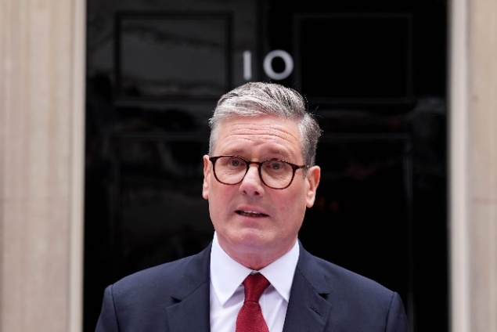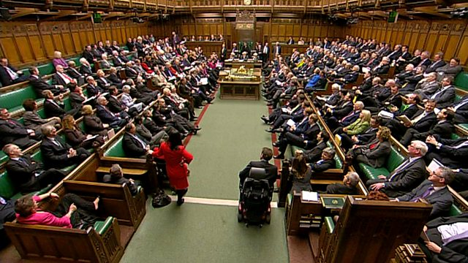
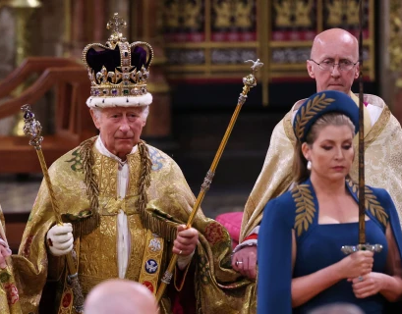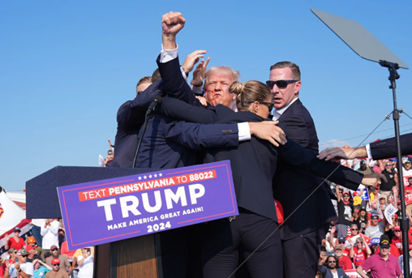
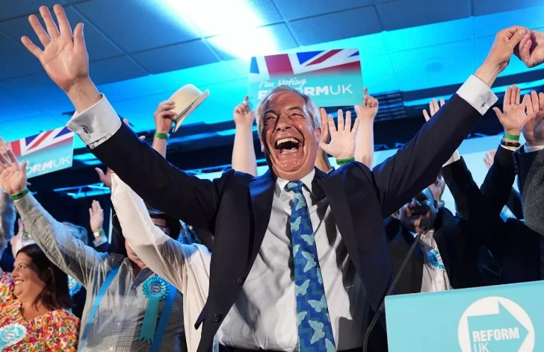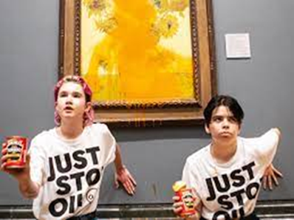

Welcome to A Level Politics at Chesterfield College’s Sixth Form Centre.
Here are some activities and resources to prepare you to start
A level Politics in September

Short answer research questions
Carry out some internet research to answer these short questions
about Government and Politics in the UK.

You might find these websites useful
www.theyworkforyou.com www.parliament.uk/about/how/
www.royal.uk/ www.supremecourt.uk/

- What is democracy?
- What is an MP?
- How are MPs chosen?
- Who is your local MP and which political party do they represent?
- Where is the House of Commons?
- What is parliamentary sovereignty?
- When did King John sign the Magna Carta?
- What is the royal prerogative?
- Which political party is in government at the moment?
- Who is the British Prime Minister?
- Who is the Leader of the Opposition?
- How many Cabinet Ministers are there at the moment?
- What is the role of the Supreme Court?
- Does the UK have a constitution?

News report task

Have a look at some of the news sources on the right. Choose a recent event in the news that interests you and write a short report about it.  Your report should cover the following questions:  - What has happened?  - Who is involved?  - Where is this happening?  - What has caused the event?  - What might the effects of the event be?  - How do you feel about the event?  - How might someone with opposing views disagree with you? | Free news websites:  https://www.bbc.co.uk/news  https://www.theguardian.com/uk  Paid-for news websites (but you might get some free articles):  https://www.thetimes.co.uk/  https://www.telegraph.co.uk/  https://www.economist.com/  https://www.newstatesman.com/uk  To do well in A Level Politics, the best thing you can do is regularly read the newspapers or news websites and watch the national news on TV.

Do you have a political ideology?
A political ideology is a set of ideas about how to create an ideal society. Here are some of the ideologies we will study:
Liberalism | Conservatism | Socialism | Environmentalism
Traditionally represented by the Liberal Democrats  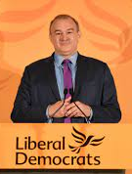  Leader: Ed Davey | Traditionally represented by the Conservative Party  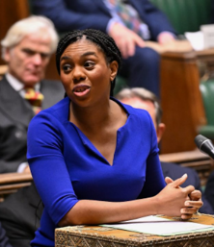  Leader: Kemi Badenoch | Traditionally represented by the Labour Party  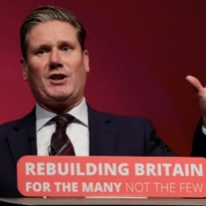  Leader: Keir Starmer | Traditionally represented by the Green Party  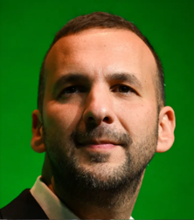  Leader: ZacK Polanski
Have a look at the Lib Dem website:  https://www.libdems.org.uk/  Write down 3 of their policies (plans):  What is your view on these policies? | Have a look at the Conservative website:  https://www.conservatives.com/  Write down 3 of their policies (plans):  What is your view on these policies? | Have a look at the Labour website:  https://labour.org.uk/  Write down 3 of their policies (plans):  What is your view on these policies? | Have a look at the Green Party website:  https://greenparty.org.uk/  Write down 3 of their policies (plans):  What is your view on these policies?

If you are interested in finding out more about your own political ideology, you can take the political compass test here https://www.politicalcompass.org/
So, you want to study Politics…
- Why does Politics interest you?
- Do you have any of your own views or opinions about Politics?
- Why is Politics important?

Think about those questions and write a thoughtful paragraph please.

What is the point of studying Politics?

Further summer reading suggestions:
If you want to do some introductory reading you might enjoy one of these
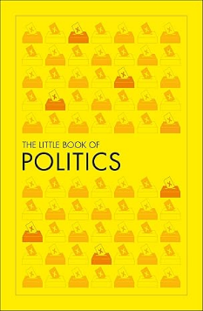
The Little Book of Politics
Publisher: DK (7 May 2020)
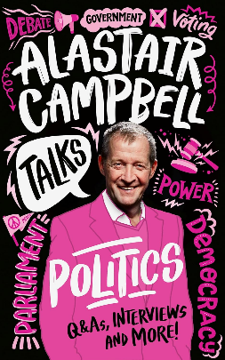
Alastair Campbell Talks Politics: An unmissable, new, illustrated non-fiction book about politics and government for young people. Publisher: Red Shed (20 June 2024)

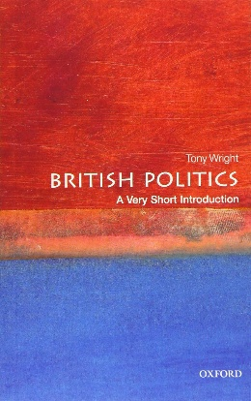
British Politics: A Very Short Introduction, Tony Wright
Publisher: OUP (25 June 2020)
Finally:
If you want a taste of academic political analysis here is a link to an article on the UK General Election 2019.
http://library.fes.de/pdf-files/bueros/london/18014.pdf
And here’s a link to a more recent article on the UK General election 2024.
https://theconversation.com/the-ten-most-surprising-facts-from-the-2024-election-revealed-271989

If you have any Politics A Level questions please contact:
Peter Meldrum meldrump@chesterfield.ac.uk

