Computer Science
Bridging Work
GCSE to AS-Level

Applying Python Skills

Name

For each of the challenges below, write a small program in Python. Copy & paste the code into this document, after the challenge.

Make sure you have an electronic copy of this document available, for your first AS-Level Computer Science lesson.
E.g. On a USB stick, or attached to a message in your personal email account, or on Google Drive.

You can install Python on your own computer from here.

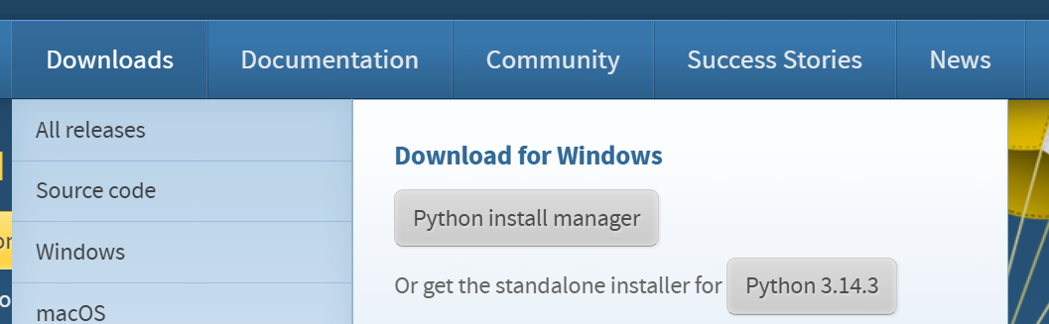

Or you can use this online editor.
Challenge 1: Piggybank

Write a program that helps the user to add up the coins in their piggy bank. The program should ask:
“How many pennies?”, “How many two pences?”, “How many 5 pences?” etc. Then it should give the total value of the coins in the piggy bank.

Code:

Challenge 2: Customer Discount

A shop is having a sale. They give 10% off when a customer spends £100 or less and 20% off when they spend over £100. Write a program that asks for the amount spent and then displays the discount to be applied and then the final price (ie with the discount applied).

Code:

Challenge 3: Blast off

Write a program that counts a blast off sequence for a space rocket, counting down from 10 to 1 and then saying ‘BLAST OFF’. You may need to import the time module, but this is optional. Use as few lines of code as you can.

Code:

Challenge 4: Times table

Write a program to print a multiplication table (a times table). At the start it should ask the user which number they want to see the times table for, by asking “Which times table would you like?”

Hints: you will need to use 2 variables and one of these will be the user input (the times table wanted). Example output: Which times table would you like?
5
Here’s your table:
5 x 1 = 5
5 x 2 = 10
...

Code:

Challenge 5: Rolling the dice

Hints: A module (or library) is a collection of useful bits of pre-written code which we can use in our own programs. They save us having to write that code – we can just import the module into our program. E.g. Import Random.
Research the Randint() function in the random module.

Write a program that simulates (acts like) rolling a die. The program should ask the user if they want to roll the die, while-ever they say yes it should tell them the number they have rolled (“You have rolled a… “). It should ask them if they want to roll again after each roll. If they say no, it should tell them the total they have rolled (“You have rolled a total of… “).

Code:

Challenge 6: Pears
A farmer wants to calculate the average weight of pears grown on her farm.
Produce an algorithm using pseudocode that meets these requirements:
- The user will provide a series of numbers, representing the weights in grams of individual fruits.
- The weights are always whole positive numbers.
- Negative numbers should not be accepted, nor should numbers larger than 200g.
- The number of weights to be entered will also be provided by the user.
- The solution should calculate and report the mean weight of the fruits to two decimal places.
Code:

Challenge 7: Bank
- Ashmia would like to invest her savings in a bank account that generates the most money. She would like a program that will allow her to:
- Enter the amount of money she wants to save.
- Input the name of bank accounts she wants to compare.
- Enter the interest rate for each account, with a max of 2 d.p..
- See a comparison of the money earned by each account, after 2 years.
- The interest is calculated by dividing the money to be saved by 100 and then multiplying this by the interest rate.
- The total is calculated by adding the money to be saved to the interest.
- The program should repeat this for all bank accounts.
- Create an algorithm using Pseudocode for the above actions.

Code:

Challenge 8: Fuel
- Petrol costs £85 per litre. Diesel costs £98 per litre. LPG costs £67 per litre. Write a program to:
- Ask the user for which type (as above) of fuel their car uses and how much they have put into it.
- Calculate the correct price of the fuel they have taken.
- Ask how much money they have handed over and calculate the amount of change they are due.
- Finally, ask them if they have a loyalty card and if they do calculate how many points they should have added to it using the following – 1 point for every litre of fuel they’ve taken plus 1 point for every 20 pounds they’ve paid.
- If the number of points they get is more than 70 they get a bonus 10% extra points.
- The number of points earned this transaction should then be outputted.
Code:

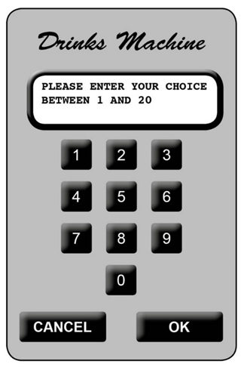
Challenge 9: Vending
- A free drinks machine in an office provides 20 different drinks.
- The machine has a small keypad with keys 0 to 9, buttons OK and CANCEL. It also has a small LCD screen.
- To get a drink, users select an item number between 1 and 20 with the keypad then press OK (use input()). If they make a mistake, they can press the CANCEL button and start again.
- If the selection is valid and the drink is available, it dispenses the drink; otherwise an error is displayed (use print()). The display screen is used to show suitable short messages throughout the process.
- The machine holds 5 drinks of each type, after it has been re-filled. Assume your program starts with a machine full of drinks.
Write a program to simulate the operation of the drinks machine.
Code:

