**Chesterfield College Sixth Form**

**AS Psychology**

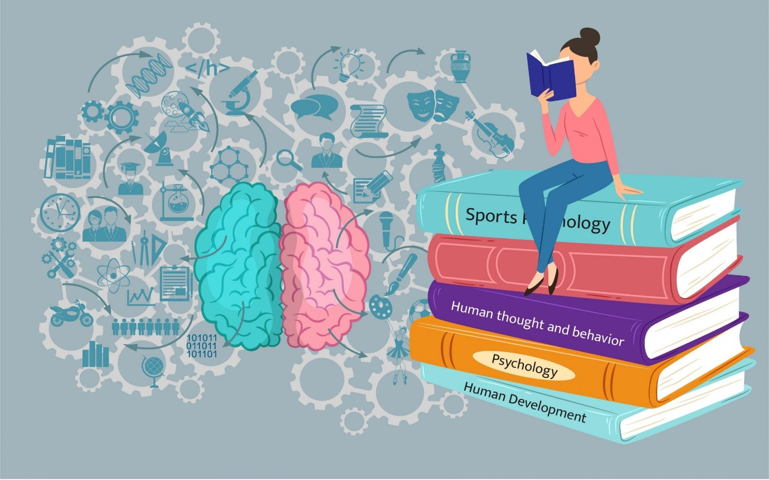

**Summer bridging work 2025**

Teaching team:

Amanda Gaughan [gaughana@chesterfield.ac.uk](mailto:gaughana@chesterfield.ac.uk)

Tiffany Whitfield [whitfieldt@chesterfield.ac.uk](mailto:whitfieldt@chesterfield.ac.uk)

Welcome to AS Psychology!

These introductory tasks are designed to give you the information you need to get started on your subject before entering the classroom.

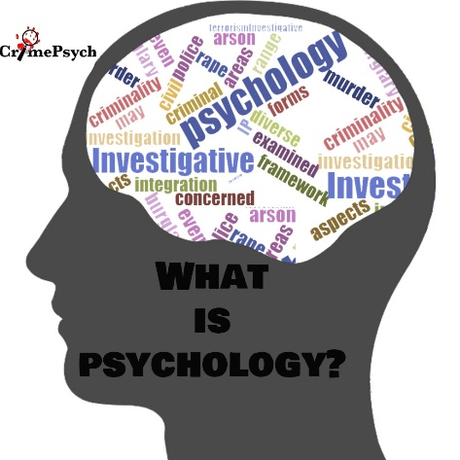

What is Psychology? Psychology is the study of the human mind and behaviour. The word “psychology” comes from the Greek word “Psyche” meaning mind, spirt or soul and “ology” meaning study of. In psychology we will explore questions such as; how are memories created? How do we learn behaviours? How does our childhood affect our adulthood? Would you hurt someone if instructed to do so? How do phobias develop? What happens if the brain is damaged? And many more questions…

**Resources to support your learning**

From September we are following a new specification, a new textbook is due to be published in summer 2025. The college will pay for a digital copy of the textbook to access however most students prefer to have a paper copy as well.

[AQA Psychology for A Level : Year 1 and AS Third edition : Flanagan, Cara, Liddle, Rob, Jarvis, Matt: Amazon.co.uk: Books](https://www.amazon.co.uk/AQA-Psychology-Level-Year-Third/dp/1036011976/ref=asc_df_1036011976?tag=bingshoppinga-21&linkCode=df0&hvadid=80401986276481&hvnetw=o&hvqmt=e&hvbmt=be&hvdev=c&hvlocint=&hvlocphy=&hvtargid=pla-4584001449027726&psc=1&msclkid=6ac421be7d161637da5b49fba11bf08f) (to be published end of June 2025)

Online resources:

[Psychology | tutor2u](https://www.tutor2u.net/psychology)

[Psych Boost](https://psychboost.com/) (also a youtube channel)

Seneca Learning [Free Homework & Revision for A Level, GCSE, KS3 & KS2](https://senecalearning.com/en-GB/)

[AQA A-level Psychology Revision - PMT](https://www.physicsandmathstutor.com/psychology-revision/a-level-aqa/)

What will you study?

From September 2025 there is a new specification for AQA AS Psychology which you will be studying.

You can read the specification here: [AQA | Psychology | AS Level | AS Psychology](https://www.aqa.org.uk/subjects/psychology/as-level/psychology-7181/specification/specification-at-a-glance) A summary of the changes to the specification can be found here: [Summary of changes](https://cdn.sanity.io/files/p28bar15/green/033e5ea9dcf3bb9ffa8f595b84930e2978d028fc.pdf)

|  |  |
| --- | --- |
| **AS Psychology (year 1)** | **A Level Psychology (year 2)** |
| This is a stand-alone qualification and is examined at the end of year 1. If you are successful you can progress to the second year of the course.  **Paper 1: Introductory topics to psychology.** You will study social influence, attachment, memory.  **Paper 2: Psychology in Context.** You will study Approaches in psychology, clinical psychology and research methods. | There are 3 exams at the end of year 2 and you will be assessed all content of both years.  **Paper 1: Introductory topics to psychology.** You will study social influence, attachment, memory & clinical psychology.  **Paper 2: Psychology in Context.** You will study Approaches in psychology, biopsychology and research methods.  **Paper 3: Issues and options in psychology.** You will study Issues & debates, Gender, Schizophrenia and Forensic psychology. |

**Assignment Tasks**

**TASK 1 – Introduction to approaches in psychology.**

In psychology, you will study the different “approaches” in psychology. Each approach has its own set of assumptions to how you can study behaviour and how to explain behaviour.

There are six approaches in psychology. For each approach, carry out some research and write a brief description of its main assumptions. The first approach has been done as an example for you.

|  |  |
| --- | --- |
| Approach | Brief description |
| Psychodynamic | The psychodynamic approach was influenced by the work of Sigmund Freud and believes our behaviours are influenced by our unconscious drives and our early childhood experiences. The psychodynamic approach uses idiographic methods (case studies) to study behaviour and the mind. It is not possible to study the unconscious mind directly and therefore it cannot be studied using scientific methods. |
| Behaviourist |  |
| Biological |  |
| Cognitive |  |
| Social Learning Theory |  |
| Humanistic |  |

**TASK 2 – Ethics in Psychology.**



To study behaviour of interest, psychologists carry out research studies. Modern research should avoid ethical issues in their research where possible to protect and respect the participants taking part in the research.

The five ethical guidelines psychologists should follow are…

|  |  |
| --- | --- |
| Informed consent | Participants should be made aware of the aim of the study and what they are required to do within the study prior to the start. If they agree they will sign a consent form which states, the details of the study. |
| Deception | Participants should be told the true aim of the study they are taking part in. |
| Right to withdraw | Participants should be told they have the right to leave a study at any time. |
| Confidentiality | Participants details and identity should remain confidential; this involves removing any names or personal information when the research is published. |
| Protection from physical and psychological harm | Participants in the study must be protected from any physical or psychological harm which is more than they would experience in day-to-day life. |

**Review the following research studies on the next page and determine if any of the above ethical guidelines have been broken?**

**Study 1**

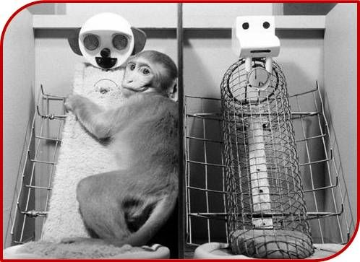Baby rhesus monkeys are separated from their mothers to investigate attachment in infants. The monkeys are kept in cages where there is a substitute wire mother which dispenses milk from a bottle and a second substitute mother is covered is a soft cloth but does not dispense milk. The researcher records how much time the monkeys spend with each substitute mother. They also scare the monkey with a noisy robot to see which mother it runs to for comfort.

**Does this study follow the ethical guidelines? Yes or No**

**Explain your answer referring to the ethical guidelines.**

**Study 2**

A researcher investigates helping behaviour of members of the public on a subway train. One member of the research team boards the subway train at a busy time of day, acting as a drunk person holding a glass bottle in a paper bag. Shortly after the train starts to move, they pretend to collapse. Two other members of the research team are secretly observing how long it takes for someone to help them. In another condition, the same actor role plays a person with a disability using a walking stick before collapsing on the train. The researchers compare the helping behaviour in both conditions. The members of the public are not aware this is a psychological experiment.

**Does this study follow the ethical guidelines? Yes or No**

**Explain your answer referring to the ethical guidelines.**

**TASK 3 – Nature vs Nurture Essay**

Write a short essay approximately 600 words (about one A4 and a bit) using your English skills from GCSE.

**Discuss the influence of nature and nurture on the development of mental disorders (e.g., OCD, phobias, depression).**

Your essay should include:

* An explanation of the nature nurture debate
* Description of **one** mental disorder to discuss of your choice
* An explanation of the influence of **nature** on the mental disorder
* An explanation of the influence of **nurture** on the mental disorder
* Other explanations e.g. **interactionist approach** or **diathesis stress model.**

**Useful resources to help you with the bridging work.**

|  |  |
| --- | --- |
|  | Log into the online Year 1 Textbook for AS psychology using the following URL, Username and Password: URL: <https://www.illuminate.digital/aqapsych1/> Username: SCHESTERFIELD  Password: STUDENT  The “psychopathology” will be useful for the essay task. |
|  | Additional resources to support you: Tutor2u has a wide range of free resources and activities to support your learning. [Psychology | tutor2u](https://www.tutor2u.net/psychology) |
| Simple Psychology | Simple Psychology is another great resource to explore content for the course. [A-level Psychology AQA Revision Notes](https://www.simplypsychology.org/a-level-psychology.html) |
| Tutors at Chesterfield College – if you are struggling with any of the tasks please feel free to email one of your course tutors. We are happy to help | Amanda Gaughan – [gaughana@chesterfield.ac.uk](mailto:gaughana@chesterfield.ac.uk)  Tiffany Whitfield – [whitfieldt@chesterfield.ac.uk](mailto:whitfieldt@chesterfield.ac.uk) |