**Politics**

**Summer 2025**

**Transition Pack GCSE to A Level**

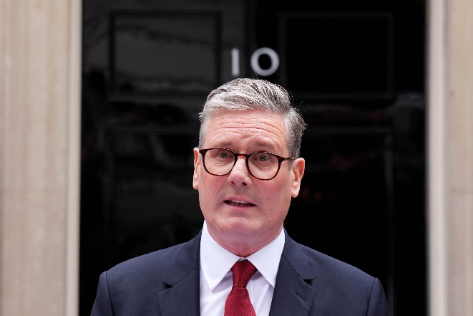 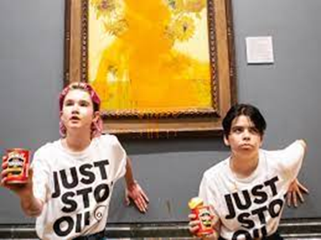

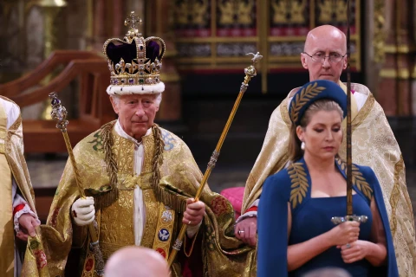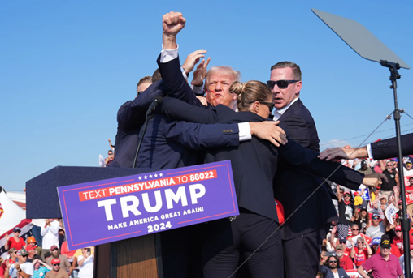

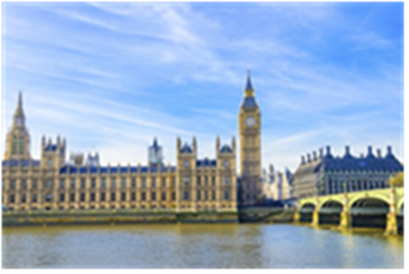

Welcome to A Level Politics at Chesterfield College’s Sixth Form Centre.

Here are some activities and resources to prepare you to start

A level Politics in September

**Short answer research questions**

Carry out some internet research to answer these short questions

about Government and Politics in the UK.

You might find these websites useful

[www.theyworkforyou.com](http://www.theyworkforyou.com) [www.parliament.uk/about/how/](http://www.parliament.uk/about/how/)

[www.royal.uk/](http://www.royal.uk/) [www.supremecourt.uk/](http://www.supremecourt.uk/)

1. What is democracy?
2. What is an MP?
3. How are MPs chosen?
4. Who is your local MP and which political party do they represent?
5. Where is the House of Commons?
6. What is parliamentary sovereignty?
7. When did King John sign the Magna Carta?
8. What is the royal prerogative?
9. Which political party is in government at the moment?
10. Who is the British Prime Minister?
11. Who is the Leader of the Opposition?
12. How many Cabinet Ministers are there at the moment?
13. What is the role of the Supreme Court?
14. Does the UK have a constitution?

**News report task**

|  |  |
| --- | --- |
| Have a look at some of the news sources on the right. Choose a recent event in the news that interests you and write a short report about it.  Your report should cover the following questions:   * What has happened? * Who is involved? * Where is this happening? * What has caused the event? * What might the effects of the event be? * How do you feel about the event? * How might someone with opposing views disagree with you? | **Free news websites:**  <https://www.bbc.co.uk/news>  <https://www.theguardian.com/uk>  **Paid-for news websites** (but you might get some free articles):  <https://www.thetimes.co.uk/>  <https://www.telegraph.co.uk/>  <https://www.economist.com/>  <https://www.newstatesman.com/uk>  To do well in A Level Politics, the best thing you can do is regularly read the newspapers or news websites and watch the national news on TV. |

**Do you have a political ideology?**

A political ideology is a set of ideas about how to create an ideal society. Here are some of the ideologies we will study:

|  |  |  |  |
| --- | --- | --- | --- |
| **Liberalism** | **Conservatism** | **Socialism** | **Environmentalism** |
| Traditionally represented by the **Liberal Democrats**  Who is Sir Ed Davey and what's the new Liberal Democrat leader's voting  record?  Leader: Ed Davey | Traditionally represented by the **Conservative Party**    Leader: Kemi Badenoch | Traditionally represented by the **Labour Party**  Labour delegates back Keir Starmer push for public vote on Brexit | Labour  conference 2018 | The Guardian  Leader: Keir Starmer | Traditionally represented by the **Green Party**    Co-Leaders: Carla Denyer and Adrian Ramsay |
| Have a look at the Lib Dem website: <https://www.libdems.org.uk/plan>  Write down 3 of their policies (plans):       What is your view on these policies? | Have a look at the Conservative website: <https://www.conservatives.com/our-plan>  Write down 3 of their policies (plans):       What is your view on these policies? | Have a look at the Labour website:  https://labour.org.uk/  Write down 3 of their policies (plans):       What is your view on these policies? | Have a look at the Green Party website: <https://campaigns.greenparty.org.uk/manifesto/>  Write down 3 of their policies (plans):       What is your view on these policies? |

If you are interested in finding out more about your own political ideology, you can take the political compass test here <https://www.politicalcompass.org/>

**So, you want to study Politics…**

* Why does Politics interest you?
* Do you have any of your own views or opinions about Politics?
* Why is Politics important?

Think about those questions and write a thoughtful paragraph please.

**What is the point of studying Politics?**

**Further summer reading suggestions:**

**If you want to do some introductory reading you might enjoy one of these**

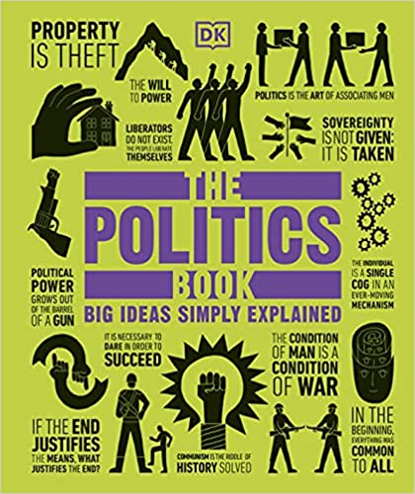

The Politics Book

Publisher: DK; UK ed. edition (1 Mar. 2013)

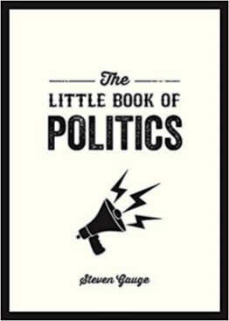

The Little Book of Politics: A Pocket Guide to Parties, Power and Participation Paperback by Steven Gauge

Publisher: Summersdale (12 July 2018)

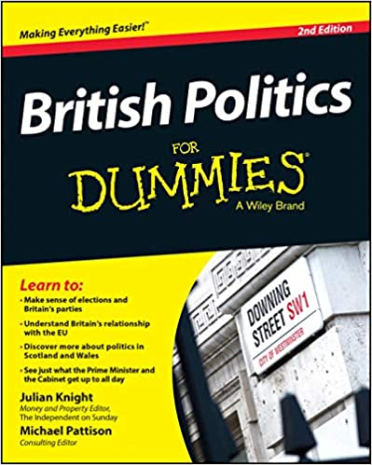

British Politics For Dummies by Julian Knight

Publisher: For Dummies; 2nd edition (24 April 2015)

**Finally:**

If you want a taste of academic political analysis here is a link to an article on the UK General Election 2019.

<http://library.fes.de/pdf-files/bueros/london/18014.pdf>

During the A Level Politics course we will be considering the relevance of some of these phrases which are mentioned in the article:

2016 Referendum, 2017 UK General Election, 2019 European Parliament elections, Brexit Party, Northern Ireland backstop, EU Withdrawal Agreement, FTPA, No-deal exit, Red Wall, Cosmopolitian, Values-divide, Generational divide, Educational divide, Get Brexit Done, Left behind

If you have any Politics A Level questions please contact:

Peter Meldrum [meldrump@chesterfield.ac.uk](mailto:meldrump@chesterfield.ac.uk)