

Philosophy
Summer 2025
Transition Pack GCSE to A Level

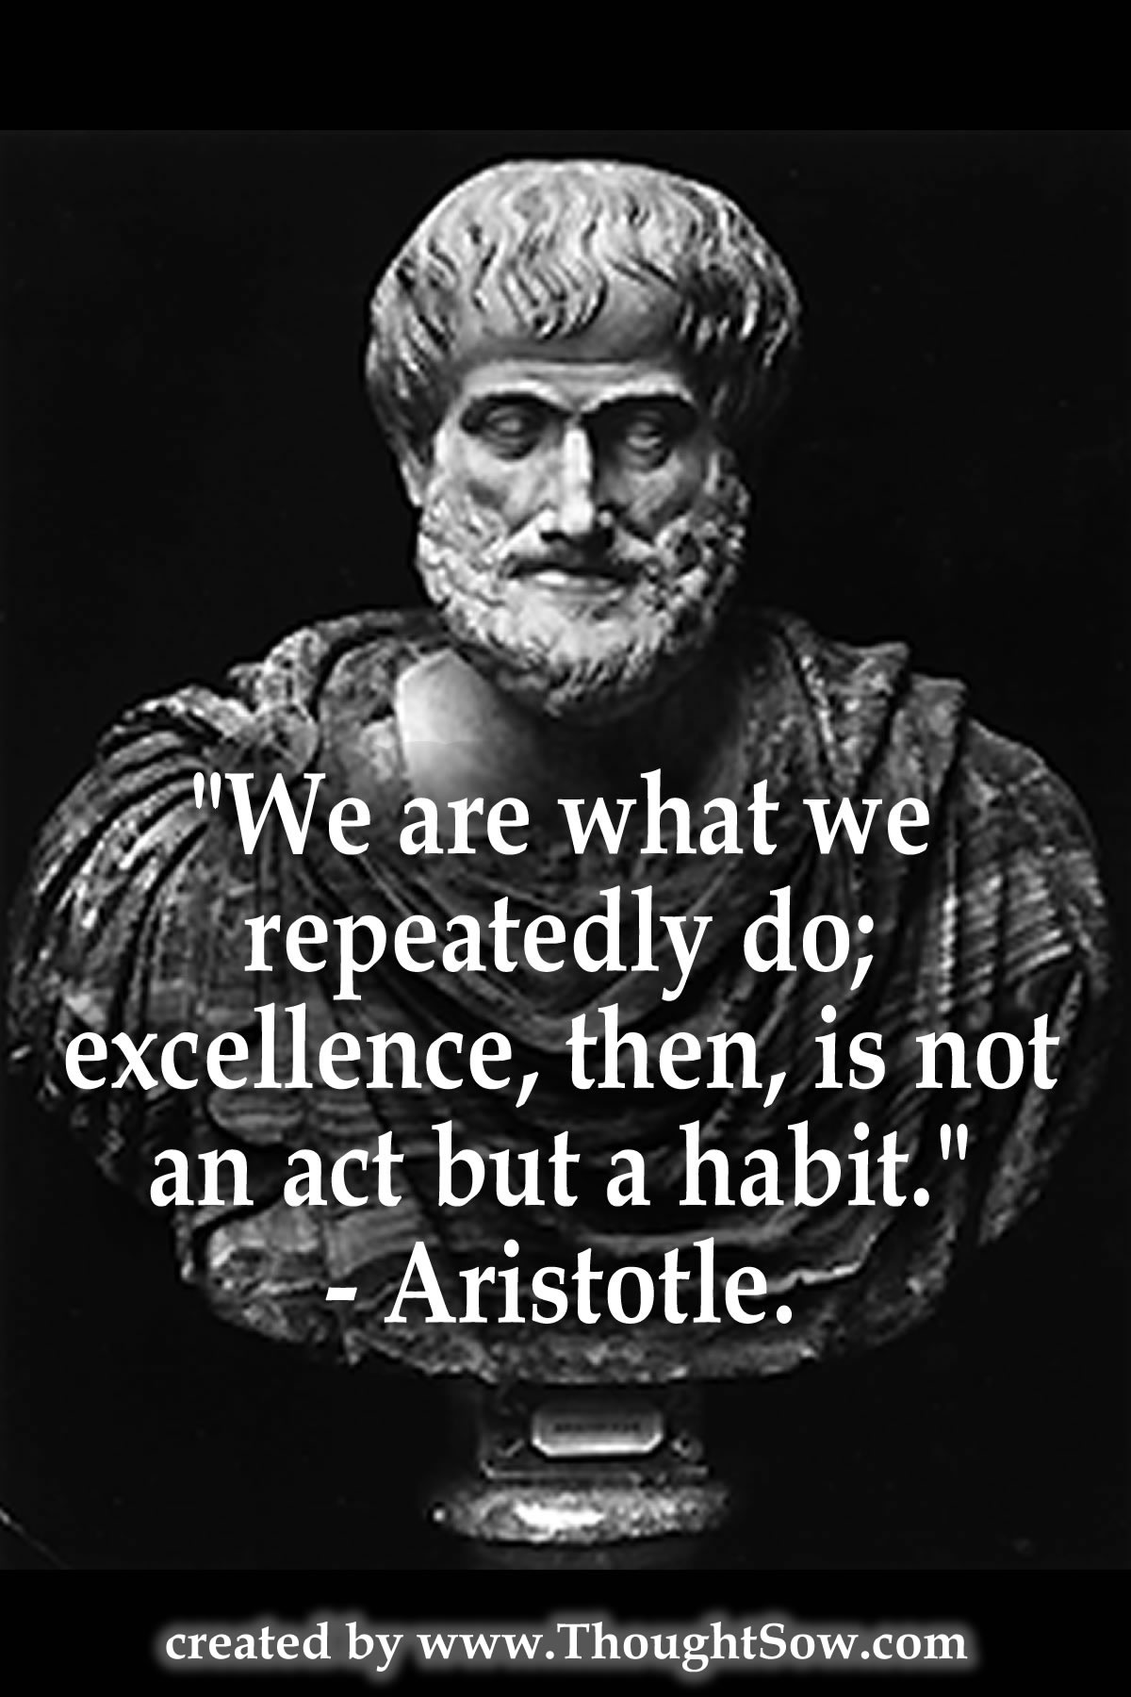



Welcome to A Level Philosophy at the Sixth Form Centre.
Here are some activities and resources to prepare you for September.

At the heart of philosophy is philosophical argument.
Arguments are different from assertions. Assertions are simply stated; arguments always involve giving reasons. An argument is a reasoned inference from one set of claims – the premises – to another claim, the conclusion. Here’s a famous argument:
Premise 1: Socrates is a man.
Premise 2: All men are mortal.
Conclusion: Socrates is mortal.

In order to test the strength of any argument it is useful to consider possible objections to the argument. If it is then possible to reply to the objection this might strengthen the argument. However, if it is not possible to reply or the reply is weak perhaps the objection is stronger than the argument and the argument is not a good one.
One way to ‘do’ philosophy is to follow this structure:
argument-objection-reply (and so on)
This can follow the form of a dialogue i.e. imagine you are having a reasoned argument with another person or persons. This is how Plato structured most of his philosophical writing.
A Practical Ethics Task
Pick one of the following issues and construct a philosophical dialogue using an argument-objection-reply structure. Imagine you are two characters, A and B, A will defend the argument and B will object.
•Eating Animals: Is it wrong to eat meat? (A will argue that it is wrong to eat meat and explain why. B will raise objections and A must then reply etc.)
•Stealing: Is it wrong to steal? (A will argue that it is wrong to steal and explain why. B will raise objections and A must then reply etc.)
•Telling Lies: Should you always tell the truth? (A will argue that you should always tell the truth and explain why. B will raise objections and A must then reply etc.)
How long can you keep the dialogue going?
To help you there is an example of the beginning of a dialogue on a different topic over the page.

Simulated killing: Is it wrong to play computer games in which you play the killer?
A: Killing people is wrong. So, playing computer games which involve simulated killing must also be wrong. If you don’t want to be a killer why would you want to pretend to kill people in a computer simulation?
B: Even if killing people is wrong (and there might be circumstances in which killing people is justified) simulated ‘killing’ is not killing. When you play a computer game you are just playing a game. It is a bit of fun and no-one gets hurt. Lighten up and stop being such a kill-joy!
A: But why would a rational human being take pleasure in pretending to kill someone else? Surely this must be wrong?
B: Many rational people find it relaxing to play these games and they are not harming anyone. Perhaps it allows people to release negative feelings which might otherwise be bottled up or released in actually violent behaviour. Maybe playing the killer in a computer game is a good thing to do.
A: I don’t accept that this is an appropriate way for anyone to release tension or negative feelings. I worry that by playing computer games and killing people as part of the game people might become desensitised to actual violence. [And so on…]
----------------------------------------------------------------------------------------------------

On the next five pages are some more activities to introduce you to different branches of Philosophy. On page 4 is a famous thought experiment in Ethics (moral philosophy). On pages 5 to 7 are a series of activities in Epistemology (the philosophy of knowledge), Metaphysics (the study of the ultimate nature of reality) and the Philosophy of Religion. On page 8 is a more detailed consideration of one of the key ideas of the ancient Greek philosopher Plato.

If you have any questions, please contact
Peter Meldrum meldrump@chesterfield.ac.uk

Ethical Thought Experiments: Solving ‘Trolley Problems’
(they call trams ‘trolley cars’ in the USA)
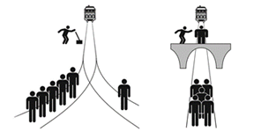

Trolley Problem | What would you do? | Why?
Switch: there are five people on the rail track, and an out of control trolley that will kill all five of them. There is a lever that would divert the trolley onto a different track. But there is a single person on that track who would be killed if you pull the lever and divert the trolley.

Bridge: there are five people on the rail track, and an out of control trolley that will kill all five of them. There is a large man standing on the bridge over the track. If you pushed him off the bridge onto the track, he would be killed. But he would derail the trolley and so the five people on the track would be saved.

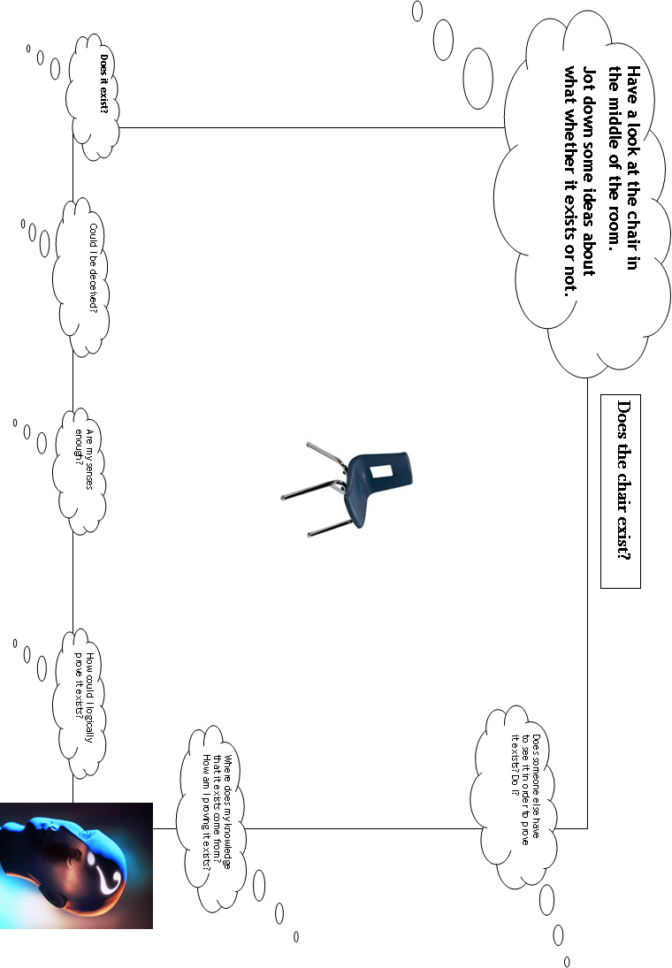

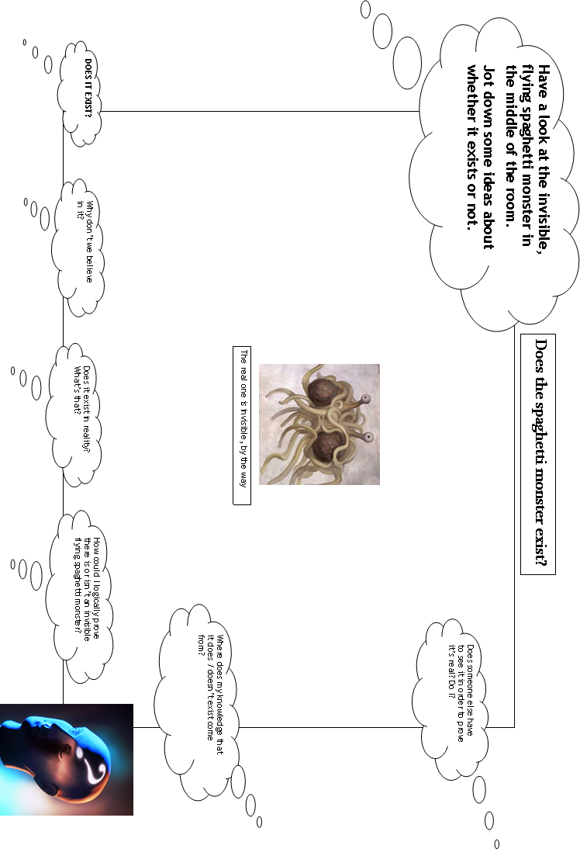

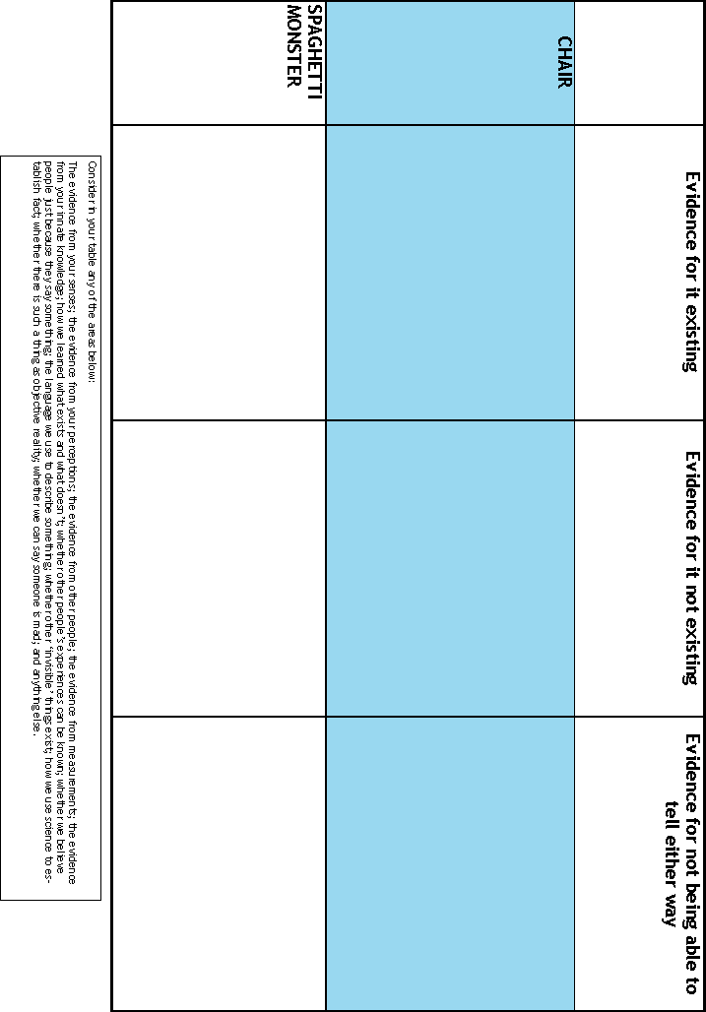

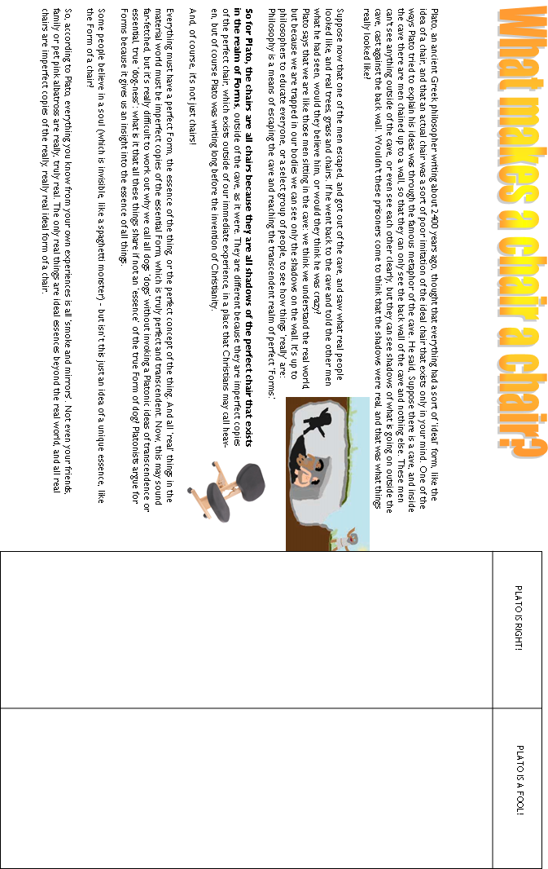

Read, Listen, Watch, Think

Suggested Reading:

A Little History of Philosophy by Nigel Warburton (Yale)
The Philosophy Gym by Stephen Law (Headline Review)
Sophie’s World A Novel About the History of Philosophy by Jostein Gaarder (Orion)

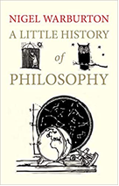 | 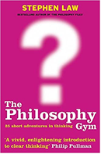 | 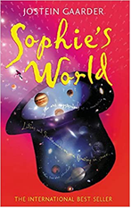

Watching:

Crash Course Philosophy
https://www.youtube.com/playlist?list=PL8dPuuaLjXtNgK6MZucdYldNkMybYIHKR

A History of Ideas
http://www.bbc.co.uk/programmes/b04bwydw

Movies:

The Matrix: Would you swallow the red pill?

Ex Machina: Does Ava have consciousness?

Bladerunner: Do androids dream of electric sheep?

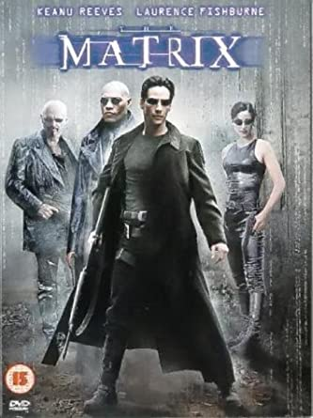 | 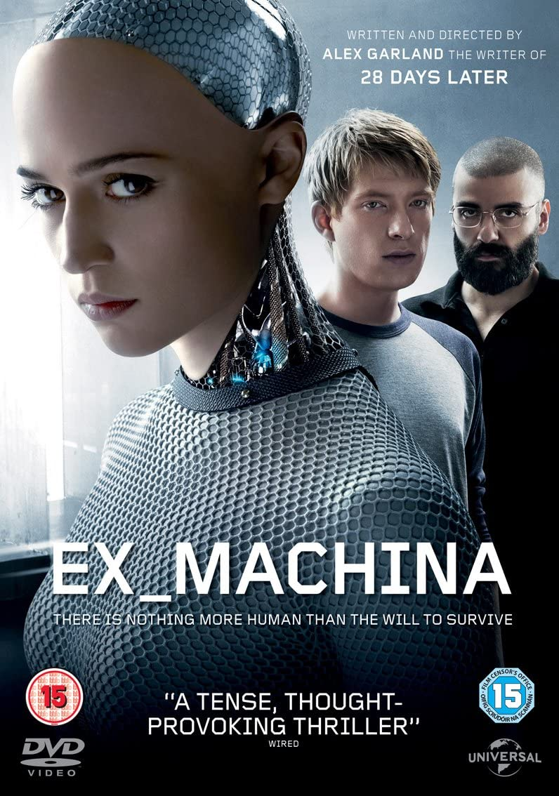 | 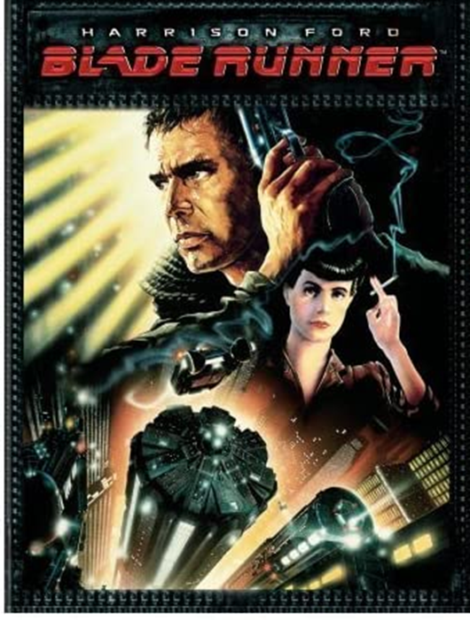
If you have any Philosophy A Level questions please contact:
Peter Meldrum meldrump@chesterfield.ac.uk

