

**Welcome to Applied Law**

Applied Law offers you an exciting alternative to study law if you prefer a course with some coursework assignments rather than exams. This fascinating course allows you to explore Law and the legal system through practical activities and by applying the law to scenarios.

To prepare you for study, we have formulated some activities that will give you an introduction to law and an insight into the types of tasks you will be expected to complete.

**You can either hand write your answers on paper or type them up and email them to myself at** [**thompsonl1@chesterfield.ac.uk**](mailto:thompsonl1@chesterfield.ac.uk)**.**





**Task 1: Research task - changes in law**

A large part of legal work is based around researching changes in law and recognising why these are necessary and the impacts they will have.

New laws may need to change or be updated to fit in line with changes in society or crime rates.

When a new law is needed, Parliament have to pass a statute and this has to go through various stages before it is approved.

Below is information regarding new laws that have either been passed or are being proposed as future law.

**Read the articles provided and answer the accompanying questions:**

**The law on disposable vapes**

[Disposable vapes to be banned in England and Wales from June - BBC News](https://www.bbc.co.uk/news/articles/cd7n3zyp114o)

1. What rules are the government planning to put in place?
2. Why are they changing the law?
3. What are some problems that may arise from this change of law?

**The suggested introduction of the Crime and Policing Bill 2025:**

[New powers for police to tackle neighbourhood crime as flagship Crime and Policing Bill enters parliament | Neighbourhood Watch Network](https://www.ourwatch.org.uk/news/new-powers-police-tackle-neighbourhood-crime-flagship-crime-and-policing-bill-enters)

[Phone thieves and anti-social behaviour targeted in crime bill - BBC News](https://www.bbc.co.uk/news/articles/cr5269qn5jvo)

[Child exploitation and cuckooing to be made criminal offences - BBC News](https://www.bbc.co.uk/news/articles/clydvlr8858o)

1. In the year ending 2024, how many antisocial behaviour incidents were recorded?
2. How many shop offences were recorded?
3. What will police be able to seize without a warrant if the new law is enforced?
4. Choose 6 of the key changes are being introduced. How will they benefit society?
5. Are there any issues or criticisms that may arise from the introduction of this law?

**Task 2: Close analysis of a key area of law:**

**Joint enterprise**

Joint enterprise is one of the most controversial areas of law, despite it being around for many years.

Watch the short clip and read the article to answer the following questions:

[Joint Enterprise: The Case for Reform](https://www.youtube.com/watch?v=LsQLnJ8r5c4)

[**The Memo: What is joint enterprise and why is the CCJS pushing for reform? - Chambers Student Guide**](https://www.chambersstudent.co.uk/commercial-awareness-memo/the-memo-what-is-joint-enterprise-and-why-is-the-ccjs-pushing-for-reform)

1. What is the law on joint enterprise?
2. Why is there controversy around this law?
3. Using one of the cases named in the article or your find your own, describe how the law on joint enterprise has been used before.
4. How do you think the law on joint enterprise relates to knife crime? You may need to do some research on this!

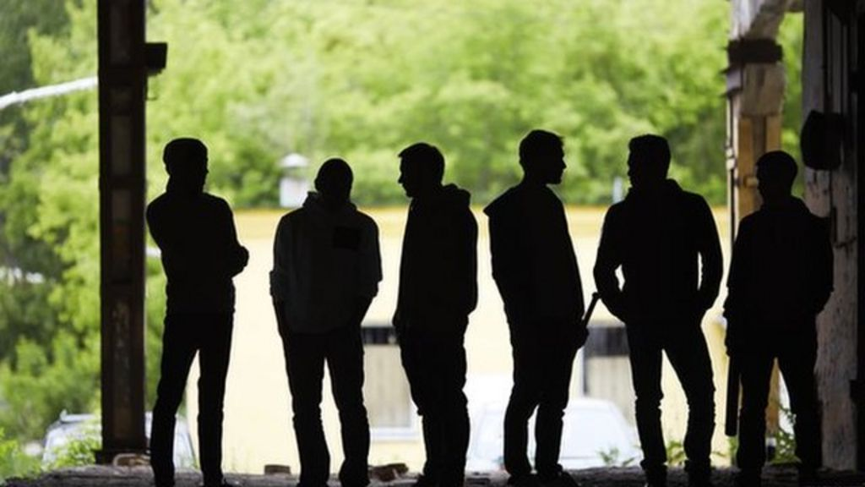

**Task 3**: **Opinion article:**

To achieve a distinction in your coursework, you may be asked to research an area of law, discuss how it works and give your opinion on whether or not it is fit for purpose.

Below is a link to the suggested reform of law around knife crime in the UK.

[Crime and Policing Bill: Knife crime factsheet  - GOV.UK](https://www.gov.uk/government/publications/crime-and-policing-bill-2025-factsheets/crime-and-policing-bill-knife-crime-factsheet)

Using this for support and any other sources you may wish to access, answer the following question:

**Knife crime is on the rise in the UK, despite efforts from the government to tackle this. In your opinion, write an article as to why you think knife crime is such an issue and suggest reasons as to how the government could reduce this.**

This could include possible punishments, education, new stop and search rules etc.

I look forward to hearing your suggestions.