History
Summer 2025
Transition Pack GCSE to A Level
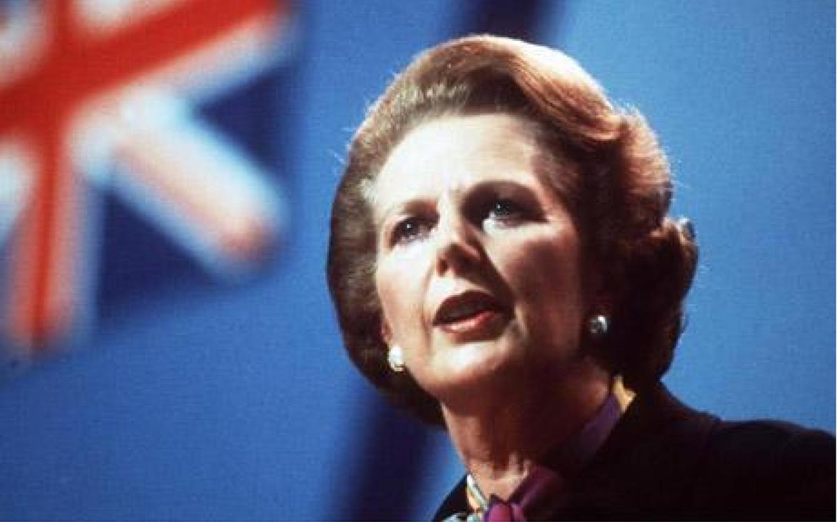
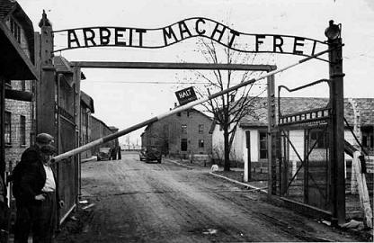

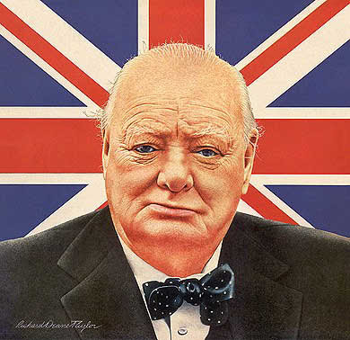

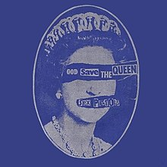
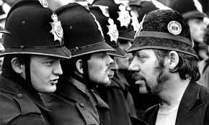

Welcome to A Level History at Chesterfield College’s Sixth Form Centre.
Here are some activities and resources to prepare you to start
A level History in September

Short answer research questions
Here are two topics we will study in the first year.
Carry out some internet research to answer these short questions.

Germany 1919-1933
- When was the armistice at the end of the First World War?
- Name the peace treaty that Germany signed in 1919.
- Where in Germany did the 1923 putsch take place?
- What was the name of Adolf Hitler’s book?
- Who became President of Germany in 1925?
- How did the Nazis do in the 1928 Reichstag elections? (% and seats)
- Name an event in the USA in 1929 which caused economic crisis in Germany?
- In which Reichstag election did the Nazis become the largest party?
- When was Hitler appointed Chancellor of Germany?
- Name one law/act created by the Nazis in 1933.

Britain 1951-1979
- When did Winston Churchill return as prime minister and which party did he lead?
- Who made the ‘Never had it so good’ speech? When?
- Which cabinet minister resigned in 1963 after lying to the Commons about an affair?
- Who led Labour to victory in 1964?
- What action did Charles de Gaulle take against Britain in 1967?
- Name two things which were legalised in Britain in 1967?
- Who became prime minister in 1970?
- What did Britain join in 1973?
- Why was there a referendum in 1975? What was the outcome?
- Who became prime minister in 1979?

Here are some websites you might find helpful:

https://spartacus-educational.com/

https://www.britannica.com/place/Germany/History#ref524675

https://www.bbc.co.uk/history/british/launch_tl_british.shtml

So, you want to study History.

- What periods/topics most interest you? Why?
- Who is your favourite historian?
- Why History?

Think about those questions and write a thoughtful paragraph please.

What is the point of studying History?

Cause, consequence, significance and interpretations

These are all important concepts which we will be considering in A Level History. Pick ONE of the events listed below, carry out some research and produce a note on one page of A4. Make sure you cover the following:

- What happened and why?
- What were the consequences?
- Why is it a significant event?
- How was the event viewed at the time? In other words, find some contemporary evidence (a ‘primary source’) and quote it.
- How has the event been interpreted by historians? In other words, find out the views of at least one historian (a ‘secondary source’). Name them and quote them.

The ‘Spanish’ Flu pandemic  1918 to 1919  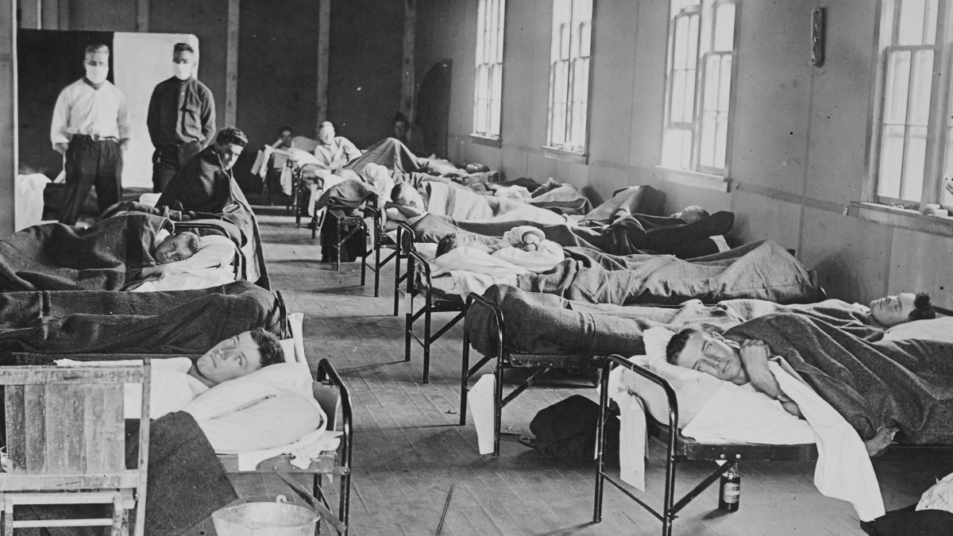 | The fall of the Berlin Wall  9th November 1989  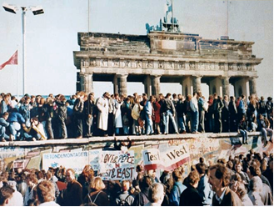
The Amritsar Massacre  13th April 1919  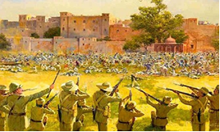 | The release from imprisonment of Nelson Mandela, 11th February 1990  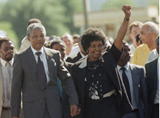

Watch and listen

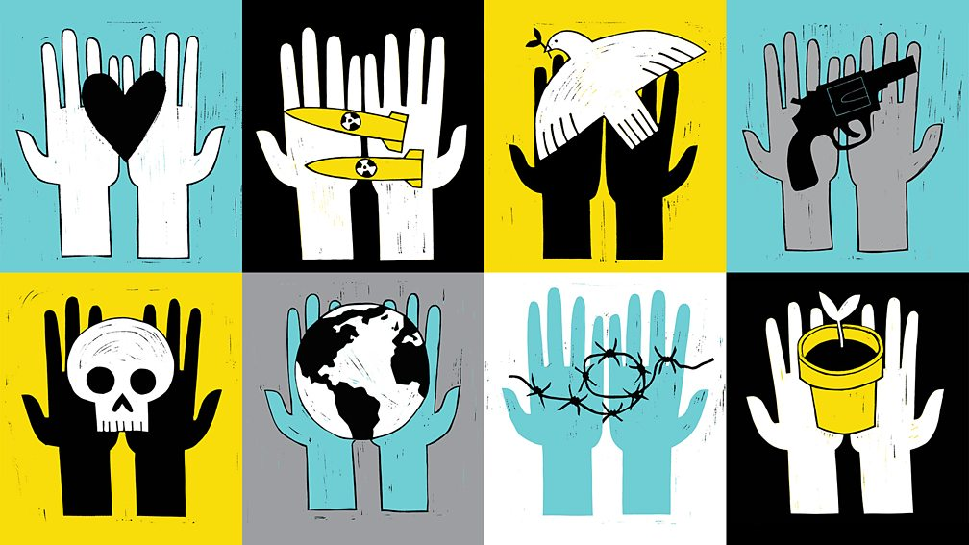

Here are links to videos and radio programmes featuring some of the historians we will be meeting during the A Level course. Please listen to/watch at least one, make some notes and be ready to discuss it.

Hitler's Place in History: The Lecture Podcast
Ian Kershaw, renowned as one of the leading experts on the Third Reich, unpicks the question of how history should view Adolf Hitler.
https://www.open.edu/openlearn/history-the-arts/history/hitlers-place-history-the-lecture-podcast

Conspiracy Theories: A Threat to Democracy?
This lecture by Richard Evans looks at recent and current research to come up with some surprising answers. Conspiracy theories seem to be everywhere nowadays, encouraged by the internet, and perhaps also by postmodern scepticism. But are they really more common than they used to be, and if so, do they constitute a threat to democracy, as a number of commentators have argued? Are they indeed more prevalent in democracies than in dictatorships?

https://www.richardjevans.com/lectures/conspiracy-theories-threat-democracy/

The Treaty of Versailles a Hundred Years Later
This is a lecture by Margaret MacMillan. The Treaty of Versailles was signed in June 1919. Did the treaty lead to the outbreak of World War II? Was the attempt to create a new world order a failure?
https://youtu.be/rkhw94PGLxs

The Reith Lectures on War and Society
This is a series of BBC radio lectures by Margaret MacMillan which explore the tangled history of war and society. WARNING: Episode three contains descriptions of rape and sexual violence perpetrated as a weapon of war on civilians.
https://www.bbc.co.uk/programmes/b0b8d340

Further summer reading suggestions:
A Little History of the World by E.H. Gombrich.

It was written in 1935 in Vienna, Austria, when Gombrich was 26 years old. He was rewriting it for English readers when he died in 2001, aged 92, in London. Written for young people of all ages and an excellent introductory guide to a big subject.

Publisher: Yale University Press
ISBN-10: 9780300143324
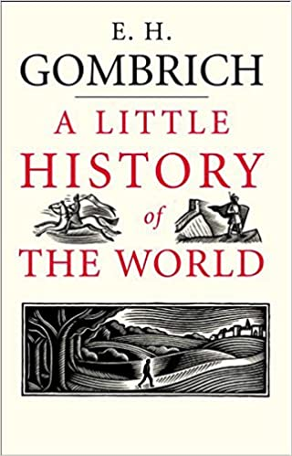
The Uses and Abuses of History by Margaret MacMillan

This is a more challenging read. History is often hijacked through suppression, manipulation, and, sometimes, even outright deception. MacMillan's book is packed full of examples of the abuses of history. In response, she urges us to treat the past with care and respect.

Publisher: Profile Books
ISBN-10: 9780300143324
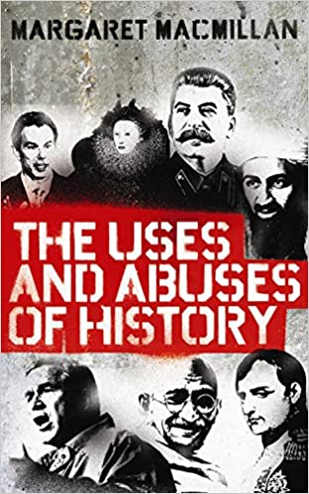

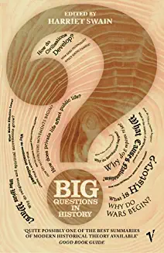
Big Questions in History edited by Harriet Swain

Drawing on examples ranging from ancient Greece to modern Britain, leading historical thinkers address 20 of the really big questions that have been asked over the centuries about the course of human events.

Publisher: Vintage
ISBN-10: 0099468468

If you have any History A Level questions please contact:
Peter Meldrum meldrump@chesterfield.ac.uk

