**



**A LEVEL**

**Geography**

**Summer Independent Learning**

**Summer 2025.**

We study 6 different topics in A Level Geography.

For you to gain some basic knowledge and understanding of what our A level course is about, have a go at completing the following tasks/answering the questions that are taken from the A level specification.

***How many can you do?*** Some are trickier than others. (You will be quizzed on some or all of these when you start college).**You can present your work in any way that you want - be creative.**

|  |  |
| --- | --- |
| Human Geography | Physical Geography |
| Changing places | Coastal systems and landscapes |
| 1. How do you think an ‘outsiders’ (someone from outside of Chesterfield) feelings about Chesterfield might be different to an ‘insiders’ (someone that lives in Chesterfield) feelings? 2. List three TNCs (Transnational Companies) that you find in Chesterfield. | 1. Draw and annotate a cross section of a sand dune system. Where can you find a sand dune? 2. Explain how sea level change has affected the island nation of Tuvalu. |
| Global systems and global governance | Hazards |
| 1. What does globalisation mean to you? 2. What are the global commons? For one of them describe and explain the threats it faces? | 1. Find out and explain what is meant by the ‘Hazard Management Cycle’. 2. Are tropical storms becoming more damaging? Explain your thoughts. |
| Contemporary Urban Issues | Water and Carbon |
| 1. What is an Urban Heat Island? 2. How is London trying to create more sustainable transport systems with fewer emissions? | 1. How do humans change the water cycle? 2. List the places that carbon is stored in (and around) the planet. |

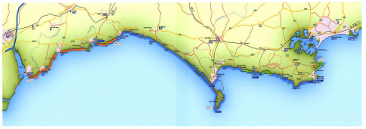 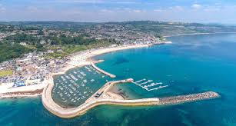

**A Level Geography Summer Independent Learning**

**COASTS**

**Checklist. Upon completion of all tasks in Section 1 and 2 -**

|  |  |
| --- | --- |
| I can explain and evaluate different methods of coastal management. |  |
| I can describe and give reasons for sea defences in **Lyme Regis, Dorset**. |  |
| I can recall key facts about the coastal management case study. |  |
| I can suggest how these strategies will be challenged by future sea level rises |  |
| My work is A Level ready; a range of ideas are explained and developed in detail; keywords/vocabulary is accurately used throughout; it has clear headings and sub-headings. |  |

**Coastal Management – Human intervention in coastal landscapes**

*Coastal management is defence against flooding and erosion, and evaluating the techniques that stop erosion to protect land. Coastal zones occupy less than 15% of the Earth's land area, while they host more than 45% of the world population.* Traditional approaches to coastal flood and erosion risk: hard and soft engineering. Sustainable approaches to coastal flood risk and coastal erosion management: shoreline management/integrated coastal zone management.

**What do I have to do?**

1. Your independent learning is **to research 6 different coastal hard engineering strategies** – provide a description of how the management work within the coastal system and research the effectiveness (advantages and disadvantages) of these different methods. See the next page.
2. Create a **case study profile** of the coastal town of **Lyme Regis in Dorset (part of the Jurassic Coast)**, as this is an illustrative example of the use of hard engineering. It includes a mix of traditional hard engineering strategies with a mix of more contemporary methods to improve the potential for sustainable management.

**How do I do it?**

* Use the following tables as a guide to help you organise your research and work.
* This should take you approximately 3-4 hours.
* You can present your case study profile in any way you want but it will need handing in within your first week of lessons.
* Please use some of the suggested resources at the bottom of this page

**Why do I have to do it?**

A Level geography is about being able to investigate and learn new theories and concepts.

An A Level geographer needs to be able to be able to think holistically and apply theory to real life.

You will be tested on your knowledge and understanding of different coastal management and be able to evaluate the importance of coastal management in Lyme Regis.

**Task 1**

Create a table or mind map *based* on the table below, explaining how each strategy protects the coasts, often each strategy is large scale and costs a significant amount of money. Your task is to ***independently* research the specific purpose of each strategy and the effectiveness** within the coastal system. **Detailed paragraphs not one-word answers.**

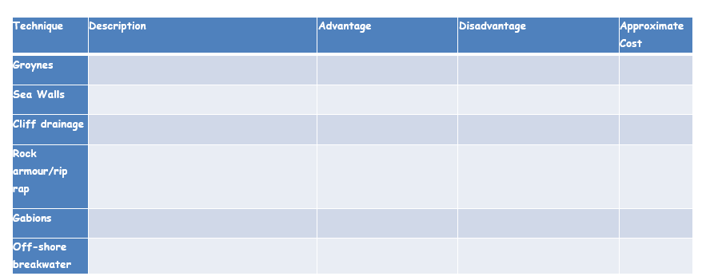

**Task 2**

**Create a case study profile** of the material you have learnt titled **Coastal management: Lyme Regis**. Be creative in your presentation of this case study. It must include the following information:

1. Background information – Why does **Lyme Regis** need protecting?
2. Which Council oversees this management?
3. What type of management schemes does **Lyme Regis** use? Suggest why each strategy has been used in each location.
4. How many phases were in this comprehensive improvement scheme and when did the programme take place?
5. Extension - Suggest how these strategies will be challenged by future sea level rises – how future-proof is the engineering in **Lyme Regis**?

**Coastal management, and hard and soft engineering approaches are topics that are well resourced in books and online - a sample of resources below:**

<http://www.alevelgeography.com/coastal-protection-and-management-hard-engineering/>

<https://www.tutor2u.net/geography/reference/coastal-protection-hard-engineering>

[L6 - Lyme Regis Flashcards Brainscape](https://www.brainscape.com/flashcards/l6-lyme-regis-5662226/packs/8529742)

**Take it further task?**

Now you have acquired new knowledge on coastal management and applied to a specific location can you retrieve this information ready for your first assessment?

Lets find out….. **Scan the QR code** to see if you can retrieve the key facts about **Lyme Regis**. A level Geography… you need to be place specific when answering exam questions!







 