**GCSE BIOLOGY**

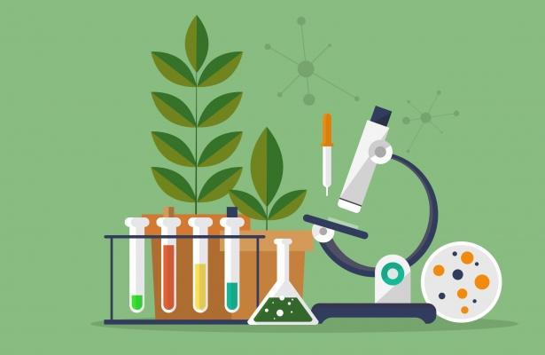**(AQA) (2024-5)**

**Bridging Work Task 2024**

**Part One:**

Choose something about Biology that fascinates you. It could be about the career you want to go into, something you saw in the Media, or something that you have been curious about (e.g. COVID vaccines). Undertake a short research task and write 300 words on your chosen topic.

Try to set out the question/topic, present some information that develops your topic (from at least two external sources [websites of books etc]) and close with an explanation of why this topic is some interesting.

**Part Two**

DNA contains the biological information for an organism. Describe the following properties of DNA:

a) Structure

b) The DNA code

c) How is genetic information passed onto human offspring. Try to explain why our offspring tend to look like both their parents.