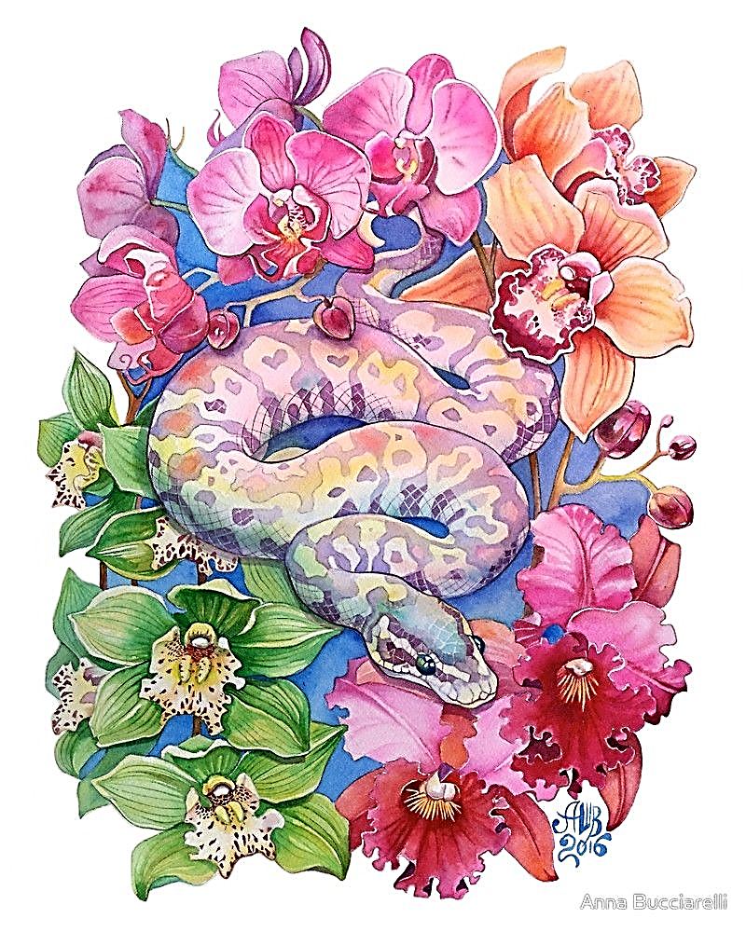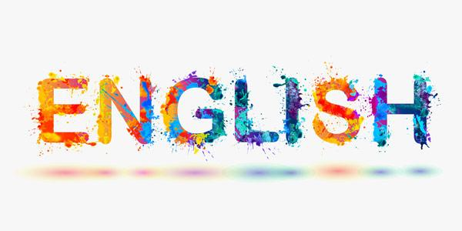

Lecturer:

Laura Rose

Rosel@chesterfield.ac.uk

English

literature

AS Level

SUMMER TASKS

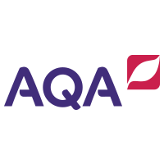

**INTRODUCTION**

A very warm welcome to your English Literature AS Level here at Chesterfield College! My name is Laura Rose and I am lecturer in English Literature and Media. I am thrilled that you are thinking of joining us. This handbook is designed to give you an overview of the course content and contains tasks to start to get you ready for the next stage of your learning journey.

**About me**

I have always had a passion for English literature going back to when I was at school! I studied Literature at York St John University and loved the classics! The Bronte’s are a particular favourite of mine 😊 if you have any questions about the course or the bridging work, don’t hesitate to get in touch! My email is:

**Rosel@chesterfield.ac.uk**

About the Course

There are four modules that you will study in the AQA A-Level English Literature B programme.

Year 1

For AS level, we will focus mainly on one of these modules, *Aspects of Tragedy*. This will involve detailed study of the following four texts:

* Shakespeare’s *Othello*
* *Death of a Salesman* by Arthur Miller
* The poetry of John Keats
* *The Great Gatsby* by F. Scott Fitzgerald

Towards the end of your first year, you will also begin work on your first piece of coursework on *Aspects of Narrative Theory*, which will involve working creatively with a piece of prose of your choice.

Year 2

As you move into year 2, we will focus on the *Elements of Crime Writing*, which will encompass study of a range of extracts across the crime fiction genre, and will include detailed study of:

* *Atonement* by Ian McEwan
* *The Murder of Roger Ackroyd* by Agatha Christie
* *The Rime of the Ancient Mariner* by Samuel Taylor Coleridge

You will also complete your second piece of coursework on *Critical Theory* which will involve analysing a collection of poetry of your choice, through a critical lens (Feminist / Marxist / Ecocritical / Postcolonial) of your choice.



Assessment Objectives

The exams and non-exam assessment (coursework) will measure to what extent students have achieved the following AOs:

• AO1: Articulate informed, personal and creative responses to literary texts, using associated concepts and terminology, and coherent, accurate written expression.

• AO2: Analyse ways in which meanings are shaped in literary texts.

• AO3: Demonstrate understanding of the significance and influence of the contexts in which literary texts are written and received.

• AO4: Explore connections across literary texts (linking to genre rather than between texts themselves).

• AO5: Explore literary texts informed by different interpretations.

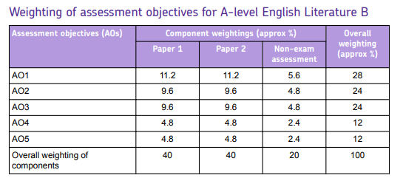



For more information on the AQA course as well as revision materials, visit the AQA website [here](https://www.aqa.org.uk/subjects/english/as-and-a-level/english-literature-b-7716-7717).

Course Overview

A broad outline of the first year is as follows:

|  |  |
| --- | --- |
| Half-term 1 | *Othello* and Introduction to Tragedy   * Introduction to tragic theory, from Aristotle to Hegel – tragic hero/character types/ narrative arcs etc. * The context of Othello and Shakespearean Tragedy * Introduction to advanced literary terminology * Detailed study of *Othello* * Exam skills – using formal, academic and critical expression and responding to an extract. |
| Half-term 2 | *Death of a Salesman*   * Detailed study of *Death of a Salesman* by Arthur Miller. * Tragic theory as applied to modern drama, with reference to Miller’s essay ‘Tragedy and the Common Man’. * The context of the play, post-WW2 America and the American Dream. * Exam skills – essay planning skills; using formal, academic and critical expression to evaluate a dramatic text. |
| Half-term 3 | The poetry of John Keats   * The poems we will cover in depth are: “La Belle Dame Sans Merci”, “Isabella: or, the Pot of Basil”, “The Eve of St Agnes” & “Lamia” * We will extend our understanding of tragic theory with reference to Nietzsche’s *Birth of Tragedy*. * Exam skills – using formal, academic and critical expression to evaluate a poetic text. |
| Half-term 4 | *The Great Gatsby*   * Detailed study of The Great Gatsby by F. Scott Fitzgerald. * Exam skills: essay planning and preparation, revision skills. |
| Half-terms 5 & 6 | Revision and Introduction to NEA 1 (First coursework assignment for A-Level course)   * Y2 begins immediately after the AS exams in summer and here we transition to the full A-Level preparation. In this way, any student whose circumstances change or who decides not to continue, will still have a qualification (AS) and UCAS points. * In this unit, we will look at a range of different critical perspectives including: Marxism, Narrative Theory, Post-colonialism and Eco-criticism. Learners will produce their own 750 word piece of creative writing based on an existing prose text of their choice, as well as a 750-word commentary evaluating their choices, comparing their own work to the base text. |

Assessments, Marking and Feedback

Each half-term will include a minimum of two assessments, completed either in or out of lesson. These will be assessed and annotated with both a mark and feedback. You are then expected to improve or respond to the feedback that is given. All your marks will be recorded on our online tracker as well as your tracking sheet at the front of your assessed work folder(which I will provide, and which should be stored in the classroom). Although your Target Grade will always remain the same (based on GCSE average) your Predicted Grade can, and will, change depending on your performance throughout the year.

Key Assessment Dates Y1 (Specific dates to be confirmed):

* First AS Mock Exams (Paper 1A): December 2025
* Second AS Mock Exams (Paper 2A): April 2025
* AS Exams (Papers 1A and 2A): May 2025
* Deadline for NEA 1 (coursework): September 2026

Equipment

The only essentials you will need in English on day one is a pen and some paper, as well as **your copy of Othello**!

However, as you progress in the course, you might find it helpful to have your own folder for your notes, with dividers in the following sections:

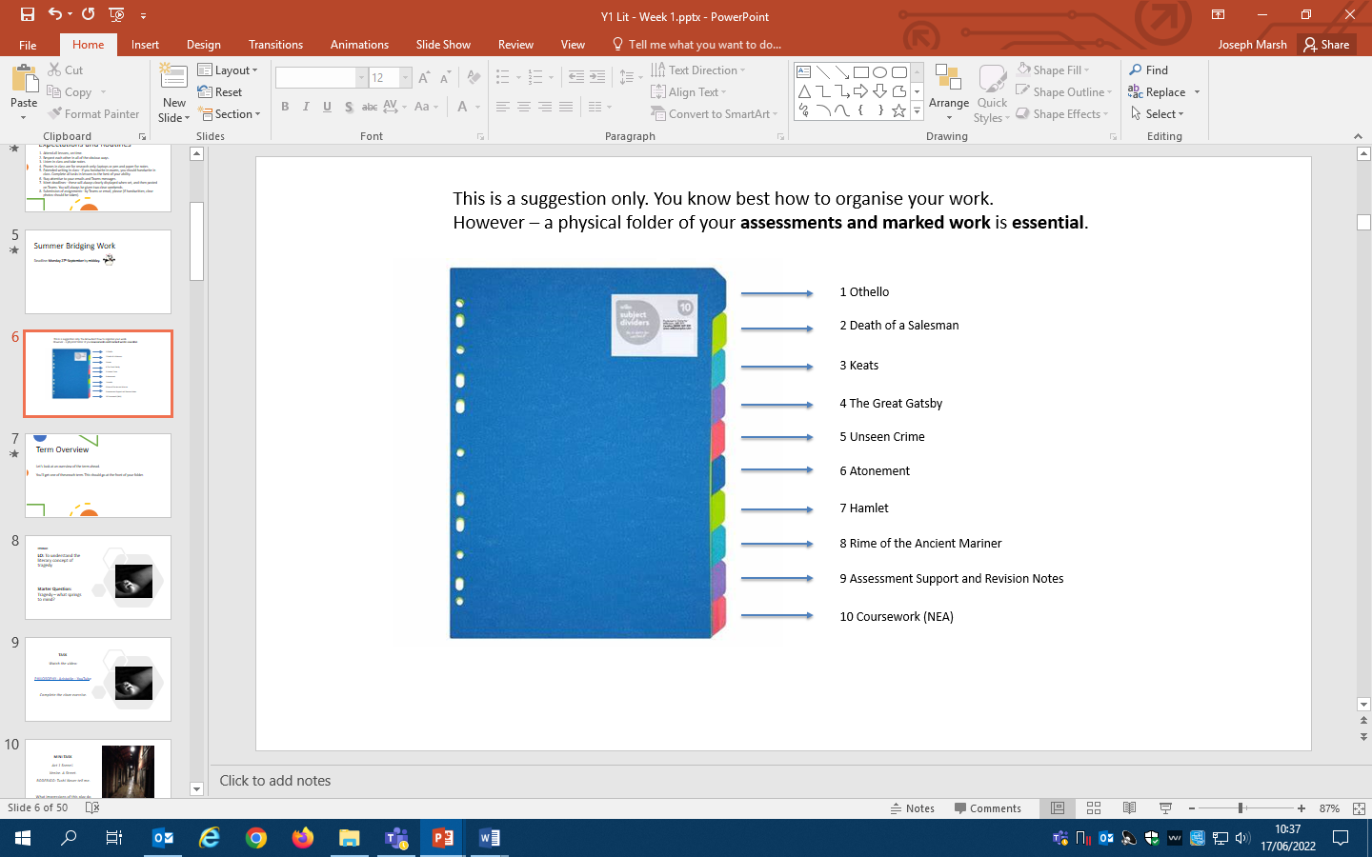

Trips

Throughout the year you will have the opportunity to participate in visits to enrich your learning, such as lectures/workshops held by visiting Senior Academics as well as off-site trips as well as performances of the text. We have been very fortunate to work closely with the English Faculties at both Sheffield Hallam and the University of Sheffield and will continue to do so over the forthcoming year.

Texts and Textbooks

It is **essential** to purchase your **own copies of the texts** that we study (except for Keats’s poetry which I will provide). These can be second-hand copies, as long as they are in good enough condition and mainly free of annotations. Here are the texts you will need to purchase for the first year, and the date by which you will need them. Click on the title to link to the recommended edition of each:

* [Othello](https://www.amazon.co.uk/Othello-Cambridge-School-Shakespeare-Gibson/dp/1107615593/ref=sr_1_1?dchild=1&keywords=othello+cambridge+school&qid=1623674744&sr=8-1) (by the start of the course)
* [Death of a Salesman](https://www.amazon.co.uk/Death-Salesman-Certain-Conversations-Classics/dp/0141182741) (by November)
* [The Great Gatsby](https://www.amazon.co.uk/Great-Gatsby-Penguin-Modern-Classics/dp/0141182636/ref=pd_lpo_card_2?pd_rd_i=0141182636&psc=1) (by March)

There are also several guides and **textbooks** that are all **optional** additions to help with the course – some recommended ones are as follows:

Cambridge English Literature B

(Can be borrowed from college) Oxford AQA English Literature B York Notes

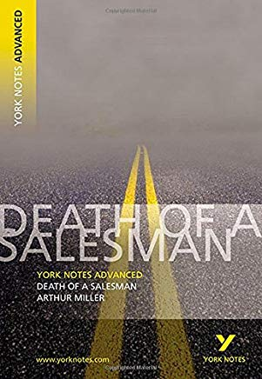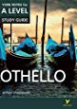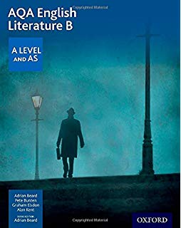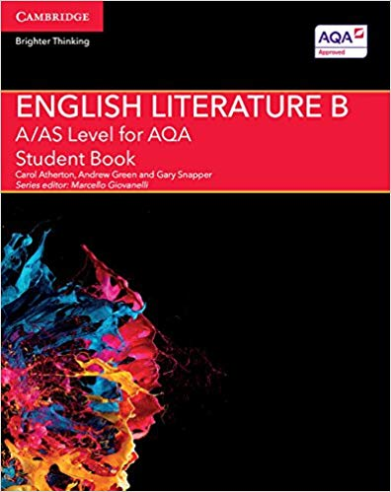

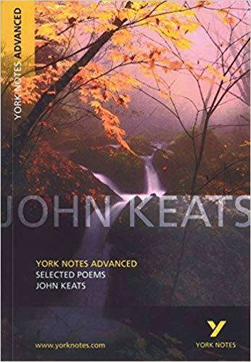

If you are unable to purchase these texts for financial reasons, **please don’t hesitate to get in touch** – support may be available.

**SECTION A: Summer Preparatory Work**

**What is tragedy?**

At the core of all the Y1 texts is a tragic hero or heroine who is flawed in some way, who suffers and causes suffering to others – and in all texts there is an interplay between what might be seen as villains and victims.

Some tragic features will be more in evidence in some texts than in others and students will need to understand how particular aspects of the tragic genre are used and how they work in the three chosen texts. The absence of an ‘aspect’ of tragedy can be as significant as its presence.

There can be no exhaustive list of the ‘aspects’ of tragedy but areas that can usefully be explored include:

• the type of the tragic text itself – whether it is classical or modern, for example

• the characters – whether it is about important public figures, like Othello, or whether it has a more domestic focus on ordinary people, like Willy Loman in Death of a Salesman.

• the settings for the tragedy, both places and times

• the journey towards death of the protagonists, their flaws, pride and folly, their blindness and insight, their discovery and learning

• the role of the tragic villain or antagonist, who directly affects the fortune of the hero, and who engages in a contest of power and is partly responsible for their demise

• the presence of fate, how the hero’s end is inevitable

• how the behaviour of the hero affects the world around him, creating chaos and affecting the lives of others

• the significance of violence and revenge, humour and moments of happiness

• the structural pattern of the text as it moves through complication to catastrophe, from order to disorder, through climax to resolution, from the prosperity and happiness of the hero to the tragic end

• the use of plots and sub-plots

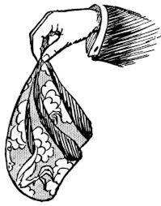• the way that language is used to heighten the tragedy

• how the tragedy affects the audience, acting as a commentary on the real world, moving the audience through pity and fear to an understanding of the human condition.

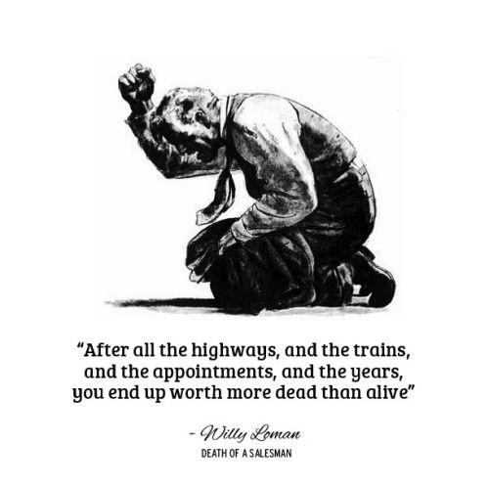

**Summer Task 1 – Research Task – Understanding Character and Plot**

It is vital to start applying theory (which is assessed in both AO4 and AO5) to your analysis of texts. Two important theorists to get used to are Todorov (plot and narrative theory) and Propp (character archetypes).

**Tzvetan Todorov – Theory of Narratology**

If you were to draw a typical plot line as a diagram, what would it look like? Todorov is well-known as one of the main theorists to cover ideas of narrative structure, and he famously came up with the structure below:

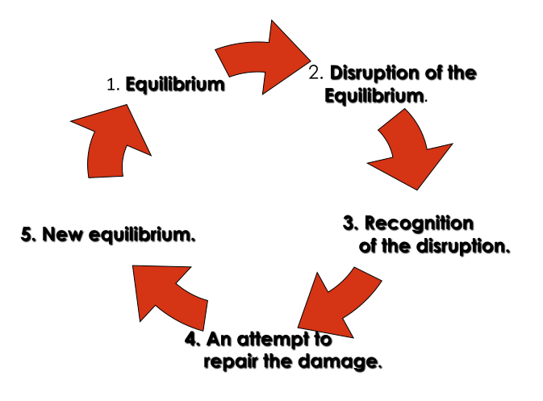

**Task 1A: Use this as a model to map out a favourite novel, film or TV episode. Research each of the stages online if you are unsure what they mean.**

**What changes have the main character(s) undergone by the end of the narrative?**

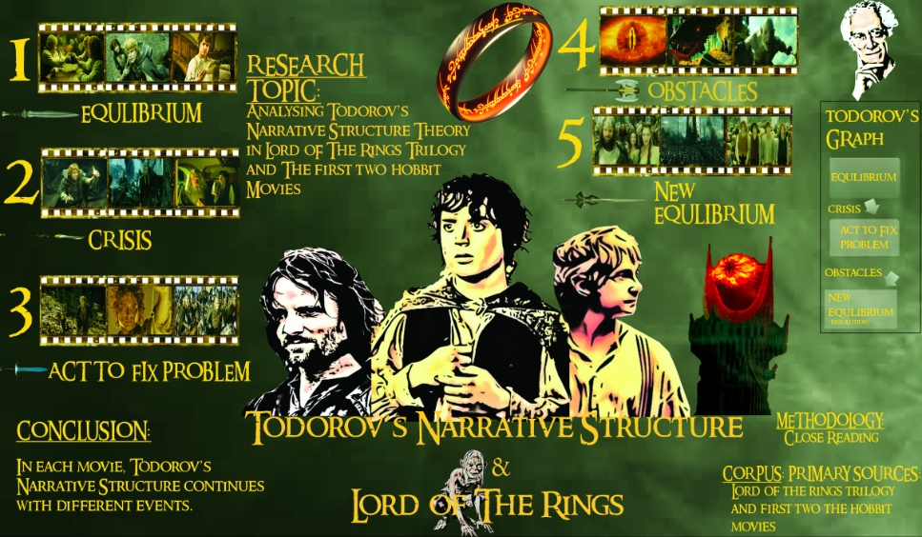

Congratulations, you are now applying literary theory to a text!

**Vladimir Propp – Character Archetypes**

Propp theorised that there were set character types in all works of fiction. These could be found in stories of all types and lengths. The main character types that he identified were:

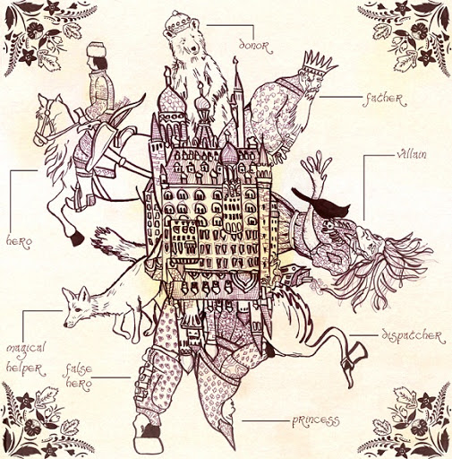

* Hero (protagonist)
* Villain (antagonist)
* False Hero (someone who seems to be good but is secretly working against the hero)
* Donor – someone who provides knowledge, items or equipment to aid the hero
* Helper – someone who supports the hero (a sidekick)
* Princess - the goal or end aim for the hero (this does not have to be a person)
* Dispatcher – this is the person or event which sets the hero off on their quest/journey.

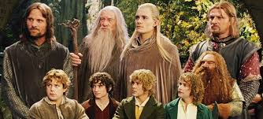**TASK 1B: Again, can you apply these ideas to a text, film or TV episode of your choice? Do any characters seem to bridge more than one definition? Are there any types missing?**

**(You can write-up your research however you choose – by hand, or on a powerpoint document, or anything in between!**

**Summer Task 2 – Reading Task – The Great Gatsby**

In March of next year, we will begin studying *The Great Gatsby* by F Scott Fitzgerald, an enthralling tragic tale set in the Jazz Age of 1920s New York. It tells the story of Jay Gatsby’s unrequited love for Daisy Buchanan.

*The Great Gatsby* is a short novel, but we won’t have time to look at every detail of it together. Instead will be focusing in on some of its key aspects that relate to our study of tragedy. For that reason, is it **essential** that you read this book in your own time before we start work on it next March.

**This summer is the perfect time to do this!** For now, simply read it and enjoy it perhaps folding down a couple of corners of pages for moments in the novel that you found particularly interesting, engaging, confusing.

Ideally, buy yourself the Penguin Modern Classics version:

<https://www.amazon.co.uk/Great-Gatsby-Penguin-Modern-Classics/dp/0141182636/ref=pd_lpo_card_2?pd_rd_i=0141182636&psc=1>

(A second-hand copy is fine, if it is in good enough condition and not already covered in annotations.)

[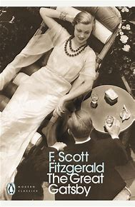](https://www.bing.com/images/search?view=detailV2&ccid=mp3cuHCl&id=91F70288F3B7E344F618027DDBC7D40267EA8769&thid=OIP.mp3cuHClNElkTmZn-sBlWwHaLX&mediaurl=https%3a%2f%2fth.bing.com%2fth%2fid%2fR9a9ddcb870a53449644e6667fac0655b%3frik%3daYfqZwLUx9t9Ag%26riu%3dhttp%253a%252f%252fwww.penguin.com.au%252fjpg-large%252f9780141182636.jpg%26ehk%3dC8w6KytXmQevl0TVbtGBjjUyj12K794hsgFWxE88hJU%253d%26risl%3d1%26pid%3dImgRaw&exph=2341&expw=1526&q=great+gatsby+penguin&simid=608047367841149845&ck=CC7D4777CB1F1E1FEF866AFA4DC4307D&selectedIndex=0&FORM=IRPRST)