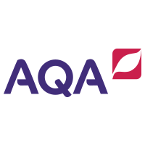

Lecturer:

Laura Hoult

houltl@chesterfield.ac.uk

English language

AS Level

SUMMER TASKS





**INTRODUCTION**

A very warm welcome to your English Language AS Level here at Chesterfield College! My name is Laura Hoult and I am a lecturer in English Language. I am thrilled that you are thinking of joining us. This handbook is designed to give you an overview of the course content and contains tasks to start to get you ready for the next stage of your learning journey. It also contains a detailed summaries of key theories, studies and terminology for your reference throughout the course.

About the Course

There are six modules in the AQA A-Level English Language course.

Year 1

At AS Level, you will focus on three of these modules:

* *Textual Variations and Representations* – here you learn how to analyse texts for meaning and representation, as well as compare texts in different genres and from different eras.
* *Language Varieties* – in this module you will learn about how geography, gender, occupation and social class all impacts on the way we use language.
* *Original Writing* – this is your first piece of coursework which will be to create an original piece of writing in a genre of your own choice.

Year 2

In Year 2, to complete you’re A-Level course, you will build upon all of the work you have done at AS Level by working on the following three modules:

* *Language Change –* here you will study where the English Language has come from, how it has changed and how it is continuing to develop.
* *Child Language Acquisition* *–* in this module you will learn about how children learn and develop speech, reading and writing from pre-birth to age 11.
* *Language Investigation* – here you will conduct an investigation into language on a topic of your choosing.

Assessment Objectives

The exams and non-exam assessment (coursework) will measure to what extent students have achieved the following assessment objectives:

• AO1: Apply appropriate methods of language analysis, using associated terminology and coherent written expression.

• AO2: Demonstrate critical understanding of concepts and issues relevant to language use.

• AO3: Analyse and evaluate how contextual factors and language features are associated with the construction of meaning.

• AO4: Explore connections across texts, informed by linguistic concepts and methods.

• AO5: Demonstrate expertise and creativity in the use of English to communicate in different ways.

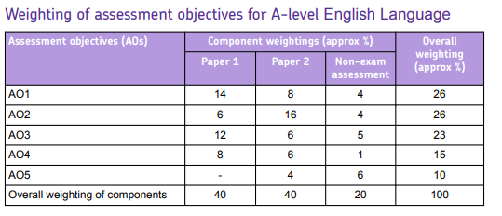

For more information on the AQA course as well as revision materials, visit the AQA website [here](https://www.aqa.org.uk/subjects/english/as-and-a-level/english-language-7701-7702).

Course Overview

A broad outline of the first year is as follows:

|  |  |
| --- | --- |
| Half-term 1 | Image result for aqa logoTextual Variations and Representations   * Introduction to features of language – semantics/ pragmatics/ mode/ register/ syntax * Articles – graphology, layout, affordances/ context * Spoken language features – paralinguistic language/ prosody etc. * Online talk and blogs * Multimodal talk – texting/social media * Standard and non-standard English – varieties of language/ formality/ accent etc. * Exam skills – using formal, academic and critical expression |
| Half-term 2 | Frameworks of Analysis   * History of print media * Older articles – graphology, layout, affordances/ context * Letters and diaries – features/ purposes/ style * Spoken language texts – newsreels/ radio/ speeches * Standard and non-standard English – varieties of language/ formality/ accent etc. throughout time * Advertisements and persuasive texts from the past * Learning to compare and contrast texts from different eras and in contrasting modes. * Exam skills – using formal, academic and critical expression to compare and contrast texts. |
| Half-term 3 | Language Diversity   * Here will explore how language changes around the UK in terms of accent and dialects. * We study how different social and occupational groups create different sociolects. * Exam skills – synthesising linguistic methods with linguistic theory |
| Half-term 4 | Language Diversity - Continued   * Here will explore how gender impacts language use. * We study how language use can be indicative of different power dynamics within a linguistic context * We will also return to some work on Textual Variations and Representations and students will begin to learn to write ‘in role’ on attitudes to language. * Exam skills – writing in role, synthesising linguistic methods with linguistic theory |
| Half-term 5 & 6 | Language Discourses and Original Writing   * In this half-term, students will learn to identify and describe features of language diversity and to research diversity for themselves. They will consider attitudes to language use and evaluate these. * By the end of Y1, coursework should be submitted in its final version and is expected to be on or above your minimum target grade. |

Assessments, Marking and Feedback

Each half-term will include a minimum of two assessments, completed either in or out of lesson. These will be assessed and annotated with both a mark and feedback. You are then expected to improve or respond to the feedback that is given. All your marks will be recorded on our online tracker as well as your tracking sheet at the front of your assessed work folder(which I will provide, and which should be stored in the classroom). Although your Target Grade will always remain the same (based on GCSE average) your Predicted Grade can, and will, change depending on your performance throughout the year.

Equipment

The only essentials you will need in English on day one is a pen and some paper!

However, as you progress in the course, you might find it helpful to have your own folder for your notes, with dividers in the following sections:

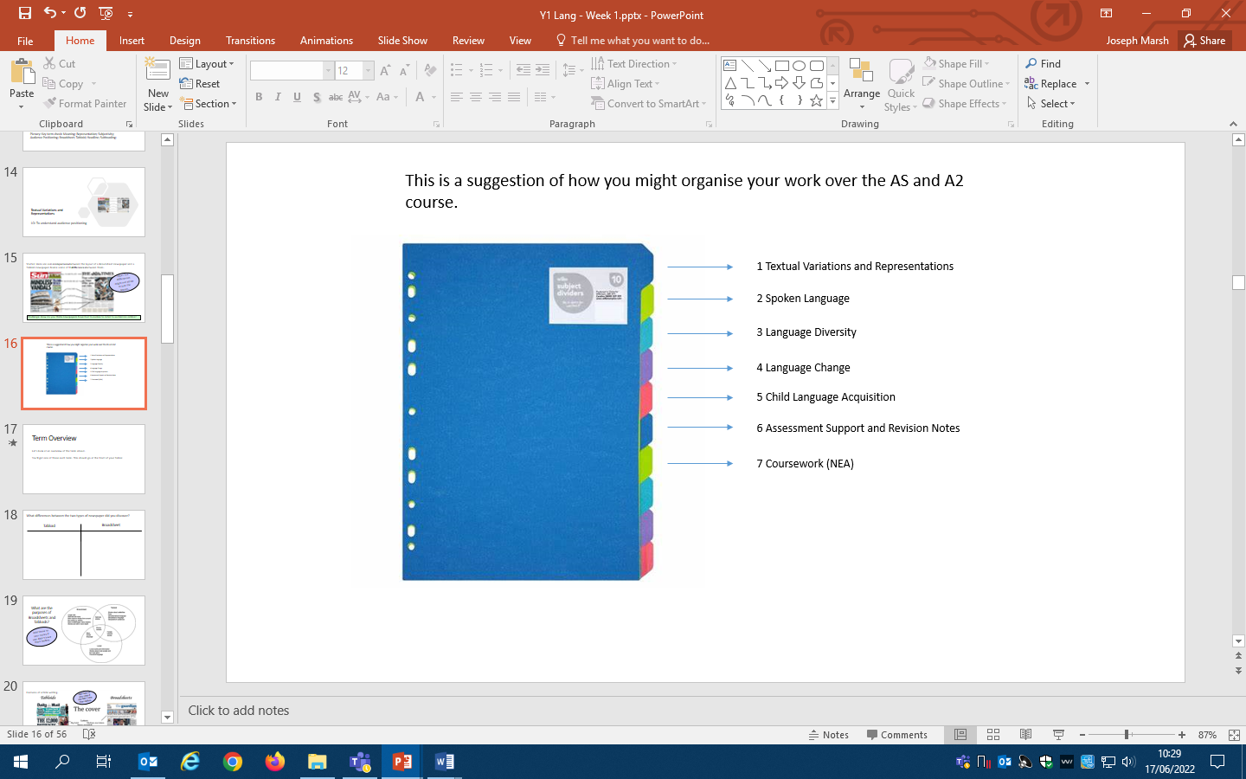

This would be in addition to your folder for assessed work which I will provide, and which should remain in the classroom at all times.

**Key Assessment Dates Y1 (Specific dates to be confirmed):**

* First AS Mocks (Paper 1): December 2025
* Second AS Mock Exams (Paper 2): March/ April 2026
* AS Exams (Papers 1 and 2): May 2026
* Deadline for NEA 1 (coursework): June 2026

Revision Guides that I recommend

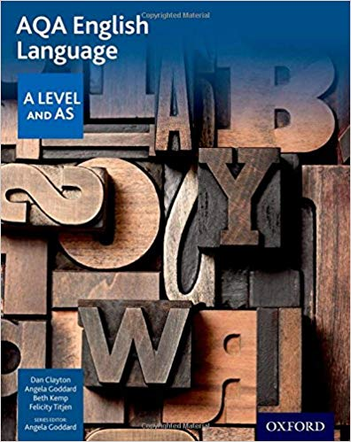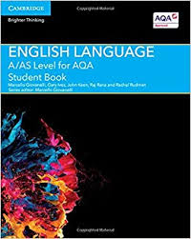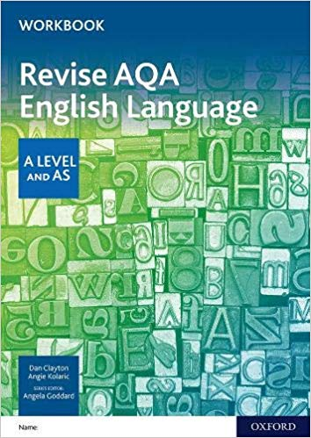

Highly recommended Optional (recommended) Optional (recommended)

**SECTION A: Summer Preparatory Work**

When we look at any text, we need to ask **GRAMPS**!

This means asking yourself some questions about –

* **G - Genre –** Specifically, what type of text is it? An online news article? An extract from a diary?
* **R - Register** – How formal is the language? Is it casual, intimate or highly formal? What kind of tone does this help to create?
* **A - Audience** – who is being addressed? In what time period?
* **M - Mode** – is the text written, or is it a transcript of spoken language?
* **P - Purpose** – What is the writer trying to achieve through their text?
* **S - Subject/Stance** – what is being discussed? What is the writer’s attitude?

Once you have got this basic overview of the text, you can start to move into analysing it for specific features. We call these frameworks of analysis, or language levels, and you can find more about them on the back pages of this document. Don’t worry if these don’t mean much to you yet, the learning on the course is designed to get you comfortable with using these accurately.

Some of the features you can focus on are:

* **Lexis & Semantics** (the words used and the meaning created)
* **Grammar** (the order and structure of words in a sentence)
* **Pragmatics** (how the context affects the meaning)
* **Discourse** (the structure of the whole text and how this creates meaning)
* **Graphology** (if written, how the text appears on the page, including text, colour, images etc.)
* **Phonology** (if spoken, how the language sounds to the listener)

**Summer Task 1 – Analysis Task – Textual Variations & Representations**

Let’s put this into practice. On the next page you will find what we call a text. This is a persuasive text, taken from a soap advert which appeared in *The Guardian* (or the *Manchester Guardian* as it was formerly known) in the 1920s – 100 years ago. The world was in recovery from a pandemic known as Spanish Influenza, which had claimed many lives.

Looking at this text (which we will call Text A), it is almost impossible to tell it is an advert as the features are so different from what we might expect in a soap or sanitiser advert today.

**TASK 1A** – Firstly, have a go at evaluating Text A. You might find it useful to highlight or annotate it first. Pick out as many features of the language and layout as you can to generate ideas for the following question:

**How does the writer use language and pictures (graphology) to persuade the audience?** (Write no more than 300 words)

**TASK 1B** – Now, try to find a soap advert from within the last year or two, online. You could print this out to hand in, but if you can’t, it is fine just to write down the web link (so I can see it). Call this Text B.

**What are the main differences between Text A and Text B? Why do you think this might be? How have they each been produced?**

Write a very simple summary (100 words) which answers these questions or create a table/diagram of the major differences and any similarities.

**Text A – Lifebuoy Soap Advert**

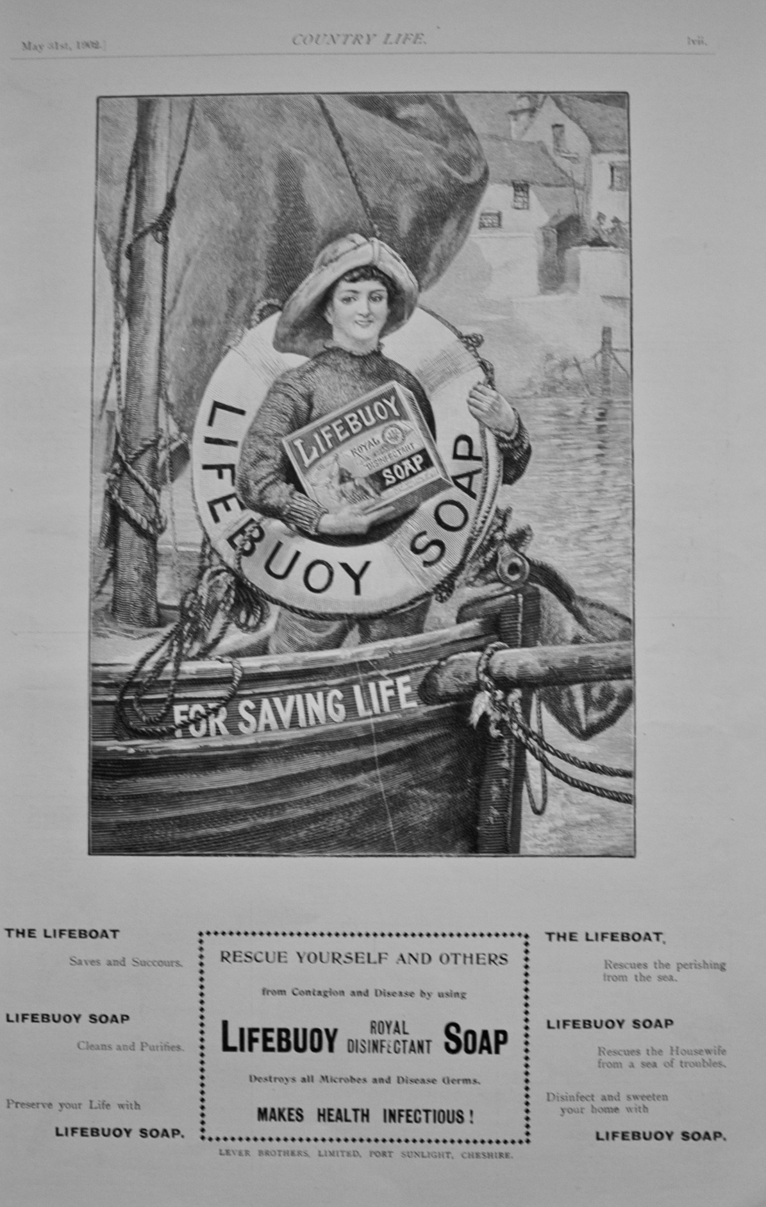

**Summer Task 2 – Writing Task – Blogs**

I would love to get to know more about you as a person as well as seeing how you write. I would like you to research features of blogs (you may or may not have encountered these before) and create a mind-map or list of the key features of this medium.

So, find an example of a blog that you particularly like, such as the one below, and see if you can identify these key features in action.

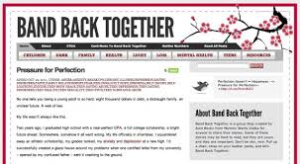

Now create a blog entry on a topic of your own choice. You can do this on paper or on a PC, it is completely up to you. It is fine to write in role (e.g. as a different person) or you can make it true to life. The topic is completely up to you, but here are some suggestions:

* A Letter to My 13 Year Old Self
* Don’t Get Me Started On…
* What Matters to Me…
* An Honest Review of…
* One Thing Which Would Make the World a Better Place Is…

There are loads of ways you can develop an A-Level in English into a lifelong career, and one is to start to write for a specific purpose. We have a 6th Form magazine which I would love you to be a part of, and we also are always looking for student content for our social media outlets…

That’s all for now – I look forward to meeting you in person and to supporting you in your learning journey!