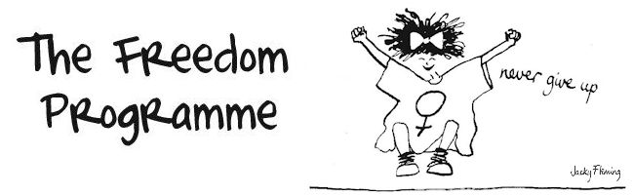

Early Help Team, Chesterfield

**Want to do all this for free, whilst giving yourself the chance to meet new people?** Then why not open the door to the

**To understand the impact on children.**

**To learn about the ‘early warning signs’ – how to recognise potential abusers.**

**To increase your self-esteem and feel more confident and in control of your life.**

**To understand the beliefs held by abusers.**

**Next Group (8 weeks)**

**Date:** **Thursday 8th September – 3rd November 2022**

(not including half term)

**Time:** **10:00am – 12:00pm**

**Venue:** **Peter Webster Centre**

**Facilitators: Chloe Webb & Eira Buckley-Allen**

**To book a place email details to:**

[Michelle.jones@derbyshire.gov.uk](mailto:Michelle.jones@derbyshire.gov.uk) and

[Chloe.webb@derbyshire.gov.uk](mailto:Chloe.webb@derbyshire.gov.uk)

**Want to learn more about the reality of Domestic Abuse?**