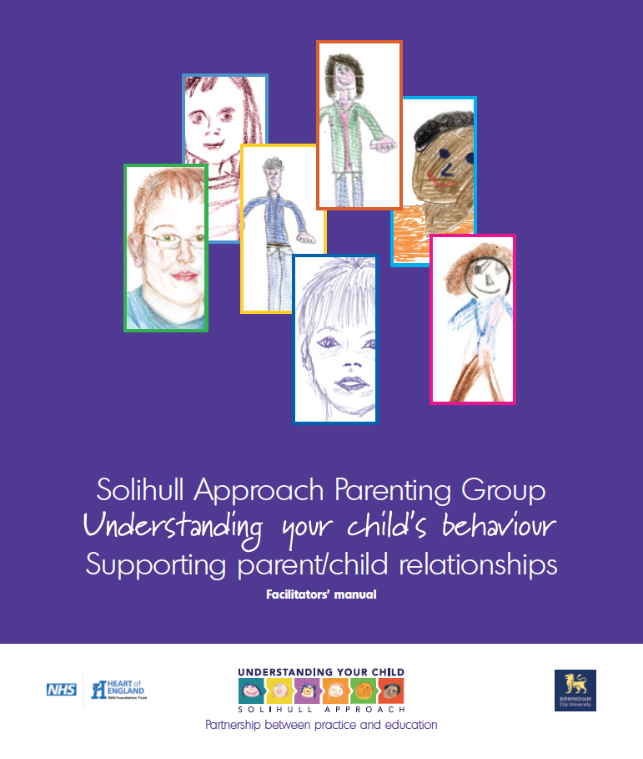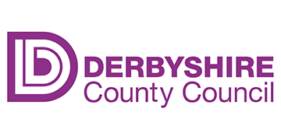

Early Help Team

Chesterfield

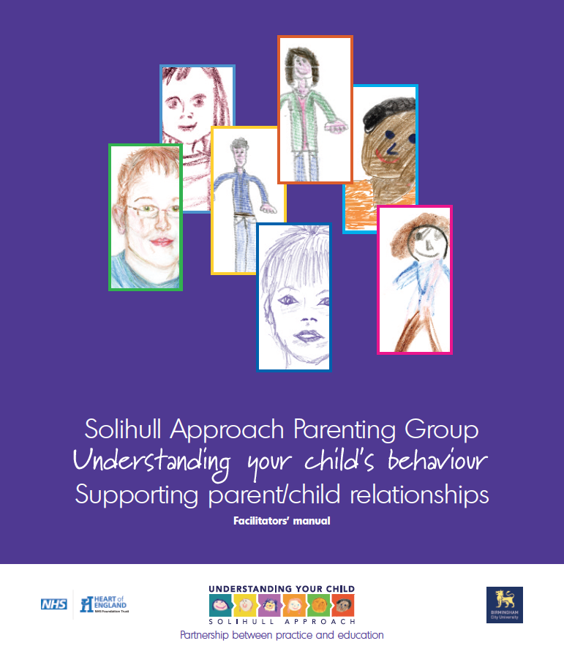

**Age range 6 – 16 years**

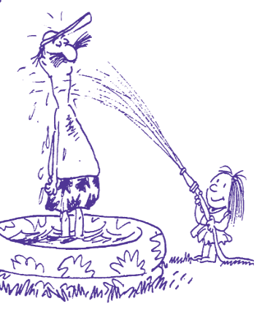

**Aim of the course:**

* To promote understanding of children’s behaviour within developmental issues
* Promote the development of parent and child communication
* Increase confidence/self-esteem in parents and children
* Give parents a strategy for repair when things go wrong
* Building relationships between parent and children
* Promote reflective, sensitive, and effective parenting.

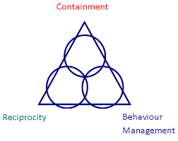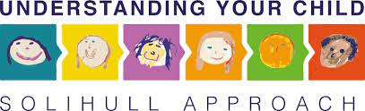

**Next Available 8 week Course – Tuesday’s**

**(Not including half term)**

**27th September**

**To**

**22nd November**

**10.00am-12.00noon**

**At Peter Webster Centre (Tiger Room), Sheffield Road, Whittington Moor**

**To book a place contact:**  [Michelle.jones@derbyshire.gov.uk](mailto:Michelle.jones@derbyshire.gov.uk) or [Charlotte.bell@derbyshire.gov.uk](mailto:Charlotte.bell@derbyshire.gov.uk)